# CHAPTER 1 Introduction

Despite the presence of dengue in Sri Lanka since the early 1960s, dengue has become a major public health issue, with a high morbidity and mortality. In mid-2009, soon after the annual monsoon, dengue infections increased at an alarming rate across Sri Lanka. By the end of the year, 35,095 people were infected, while the number of fatalities stood at 346. Since 2009 the number of infections has been steadily high; they have never fallen below 28,000. In 2014 47,246 infections was reported. While fatalities have been brought down there were 83 deaths in 2014. During the first 10 months of the year 2017, 158854 suspected dengue cases have been reported to the Epidemiology Unit of Sri Lanka from all over the island keeping the mortality rate at an alarming level which was about 300 deaths. Dengue experts and medical professionals say there is an urgent need for a comprehensive management plan to curtail the impact of the disease.

It is not that Sri Lanka has been lax on tackling mosquito breeding grounds; in fact it has initiated everything from a Presidential Task Force on Dengue Prevention, to fines for those who neglect possible breeding grounds, to declaring national dengue eradication programs. Unexpectedly, the combined result of these projects is that the rate of infection is exactly what it was five years ago, or in areas where slight reductions are reported still alarmingly high. The situation is more intensive and alarming in the Western Province, home to over 25 percent of the country’s population of over 20 million people, and to 60 percent of all reported dengue cases since 2009. Approximately 43% of the dengue fever cases were reported from the Western Province and the most affected area with the highest number of reported cases is Colombo District (18 186) followed by Gampaha (12 121), Kurunegala (4889), Kalutara (4589), Batticaloa (3946), Ratnapura (3898), and Kandy (3853).

Given that so many strategies have been tried and failed, experts are now suggesting that the authorities call in help from the national Meteorological Bureau as the latest weapon in the fight against the virus. In the work presented in [1] stated that there is a clear connection between changing climate patterns and the spread of dengue. The authors further presented that mosquito breeding grounds increased following heavy rains, pointing out that the two annual peaks in infections were recorded soon after the two annual monsoons. This work also found that warming weather patterns increased the distribution of the dengue-carrying mosquito. Researchers pointed out that detailed weather forecasts could help health authorities to better allocate resources and strategically implement prevention campaigns.

With all the information on hand mentioned above, I propose a well formulated computational approach to predict and provide guidance in mitigating dengue epidemic in Sri Lanka. In my proposed model, I take into consideration all the environmental factors as well as geological factors that may positively affect dengue vector population and the dengue cases. Contributions of my research proposal are as given below.

## 1.1 Contribution

1. **To provide a comprehensive insight into dengue epidemic and spread of the vector population based on stimulating factors.**

The foremost task to be completed before building a framework to identify and mitigate dengue epidemic is to analyze the epidemic thoroughly. There may be various factors that stimulating the spread of the dengue epidemic. These factors may contain directly related factors and hidden factors that are playing a major role in spread of the epidemic. Several major contributors of dengue epidemic have been identified by several research works conducted. Among them, temperature, rainfall, and land use appeared top in the list. All the research work conducted so far take into consideration only the global factors. And also, treat every part of the country homogenously. In reality, there is a great variation in climate, land elevation, population, temperature, and rainfall parameters among different regions in Sri Lanka. In this study, we consider global parameters and treat each region with different strategy to profoundly represent the state of the particular region throughout the country.

1. **To predict the upcoming dengue epidemic and its severity using a support vector regression.**

There is handful of work conducted to find the major stimulating factor of dengue epidemic in Sri Lanka. Despite the work that has been done, there is still a lack of dengue mitigation strategy implemented based on the research findings available in Sri Lanka. The government of Sri Lanka is deploying numerous projects to mitigate the dengue epidemic. There is still no sign of dengue in under controlled so far. The main reason behind this failure is not to identify the severity of the epidemic and its epicenter. It is very questionable to use global parameters to predict the epidemic with the fact that each region is greatly different from every other region in terms of population density, rainfall, temperature variation, land use, etc. There must be a strategy in which all the major stimulating factors along with minor hidden factors that are local to each region take into consideration. In such a setup, the developed strategy is capable of capturing the local behavioral pattern of the epidemic. This will greatly help in mitigation process. For the identification of upcoming dengue epidemic, we propose a support vector regression ensemble in which each component of the ensemble target one major or minor stimulating factor and predict the epidemic behavior for a given parameters(rainfall, temperature, population density, etc). The final result is obtained by applying the aggregation strategy on all the results obtained from each component of the ensemble. The major and minor factors may not contribute to the epidemic equally. Hence we also proposed a weight assignment system in which each parameter is given different importance in determining the status of the epidemic.

1. **To allocate limited resources efficiently to effectively mitigate the dengue epidemic**

Resources are very limited especially in countries like Sri Lanka. It is very important to utilize the available resources effectively. This poses a challenge of how to allocate limited resources among very high demanding facilities. In severe situations such as the one happened in year 2017 where all the hospitals ran out of spaces, posed a significant threat to patients due to lack of resources. All the resources were lacking including number of beds in each hospital. Resource allocation plan is a major component in response planning. Hence, I proposed a resource allocation strategy based on modified genetic algorithm (GA) optimization. The proposed resource allocation scheme can generate a resource allocation plan in a lesser amount of amount of time that is near optimum. The proposed GA modification performed higher than the standard GA.

# CHAPTER 2 MOTIVATION

## 2.1 Global burden of dengue

The incidence of dengue has grown dramatically around the world in recent decades. The actual numbers of dengue cases are underreported as the level of education and awareness of public on the dengue epidemics is low. One recent estimate indicates 390 million dengue infections per year (95% credible interval 284–528 million), of which 96 million (67–136 million) manifest clinically (with any severity of disease) [53]. Another study conducted on the prevalence of dengue estimates that 3900 million people, in 128 countries, are at risk of infection with dengue viruses [54]. The global risk map of dengue epidemic is shown in Figure 1.

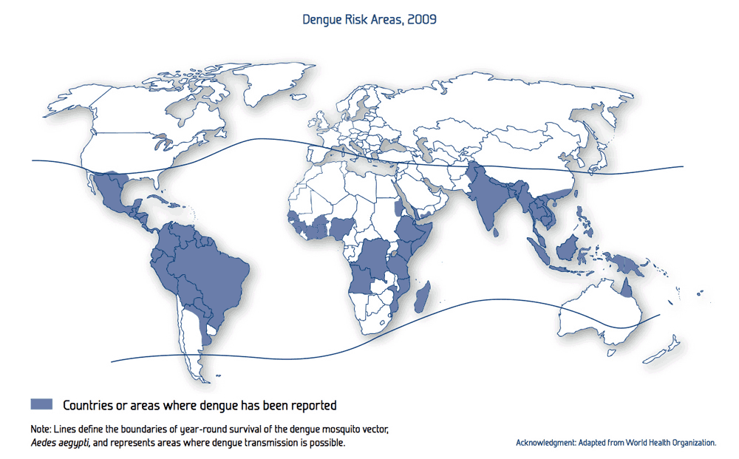

Figure 1 Dengue risk map for year 2009

## 2.2 Sri Lankan burden of dengue

It is clearly shown in the global risk map of dengue epidemic that Sri Lanka is in the high-risk area. This is not a coincidence and it is clearly reflected in the reports produced by various institutions in Sri Lanka. During the last 5 months of the year 2015, 14776 suspected dengue cases have been reported to the Epidemiology Unit from all over the island. Approximately 47.11% of dengue cases were reported from the Western province. The highest numbers of dengue cases were reported during the fourth week of 2015. The recent development of dengue epidemic in Sri Lanka is alarming. During the first 10 months of the year 2017, 158854 suspected dengue cases have been reported. The mortality rate was at an alarming level which was about 300 deaths. The distribution of dengue cases in each district for first 10 months of the year 2017 is listed in table 1. Distribution of cases by weeks is given in the Figure 2.

| **RDHS** | **Jan** | **Feb** | **March** | **April** | **May** | **Jun** | **Jul** | **Aug** | **Sept** | **Oct** | **Total** |
| --- | --- | --- | --- | --- | --- | --- | --- | --- | --- | --- | --- |
| Colombo | 2734 | 1900 | 2467 | 2570 | 3333 | 5372 | 7471 | 3620 | 1251 | 161 | 30879 |
| Gampaha | 1635 | 1087 | 1870 | 2072 | 3168 | 4901 | 9039 | 3522 | 1137 | 53 | 28484 |
| Kalutara | 581 | 448 | 836 | 739 | 946 | 1248 | 2577 | 1390 | 449 | 22 | 9236 |
| Kandy | 252 | 207 | 369 | 443 | 862 | 2314 | 3595 | 2079 | 991 | 145 | 11257 |
| Matale | 129 | 103 | 145 | 120 | 165 | 436 | 766 | 533 | 135 | 15 | 2547 |
| N Eliya | 50 | 32 | 42 | 37 | 57 | 94 | 294 | 159 | 39 | 6 | 810 |
| Galle | 872 | 567 | 424 | 265 | 394 | 623 | 1072 | 877 | 344 | 22 | 5460 |
| Hambantota | 301 | 225 | 339 | 333 | 272 | 384 | 529 | 359 | 179 | 13 | 2934 |
| Matara | 431 | 382 | 337 | 354 | 488 | 581 | 1789 | 1029 | 377 | 20 | 5788 |
| Jaffna | 625 | 478 | 863 | 499 | 301 | 288 | 376 | 290 | 298 | 62 | 4080 |
| Kilinochchi | 55 | 84 | 35 | 46 | 21 | 21 | 90 | 59 | 30 | 3 | 444 |
| Mannar | 147 | 91 | 65 | 90 | 60 | 23 | 23 | 5 | 3 | 1 | 508 |
| Vavuniya | 58 | 76 | 143 | 83 | 65 | 81 | 137 | 92 | 26 | 0 | 761 |
| Mulativu | 37 | 32 | 21 | 16 | 27 | 37 | 71 | 41 | 14 | 0 | 296 |
| Batticaloa | 217 | 465 | 828 | 1182 | 869 | 465 | 273 | 197 | 143 | 19 | 4658 |
| Ampara | 51 | 51 | 59 | 72 | 75 | 105 | 225 | 100 | 62 | 10 | 810 |
| Trincomalee | 387 | 661 | 2114 | 936 | 158 | 130 | 135 | 78 | 59 | 10 | 4668 |
| Kurunegala | 403 | 381 | 505 | 629 | 1281 | 2030 | 2300 | 1487 | 576 | 37 | 9629 |
| Puttalam | 196 | 132 | 212 | 318 | 612 | 783 | 1304 | 1192 | 419 | 111 | 5279 |
| Apura | 166 | 147 | 255 | 193 | 249 | 378 | 709 | 279 | 65 | 6 | 2447 |
| Polonnaruwa | 54 | 64 | 98 | 172 | 160 | 190 | 293 | 76 | 34 | 3 | 1144 |
| Badulla | 226 | 130 | 139 | 167 | 186 | 386 | 1171 | 470 | 226 | 4 | 3105 |
| Moneragala | 97 | 97 | 112 | 126 | 164 | 449 | 569 | 348 | 300 | 61 | 2323 |
| Ratnapura | 439 | 360 | 507 | 519 | 1161 | 1908 | 3175 | 1627 | 632 | 21 | 10349 |
| Kegalle | 210 | 230 | 377 | 332 | 700 | 1945 | 2551 | 1684 | 678 | 39 | 8746 |
| Kalmunai | 574 | 294 | 378 | 197 | 162 | 127 | 197 | 144 | 126 | 13 | 2212 |
| TOTAL | 10927 | 8724 | 13540 | 12510 | 15936 | 25299 | 40731 | 21737 | 8593 | 857 | 158854 |

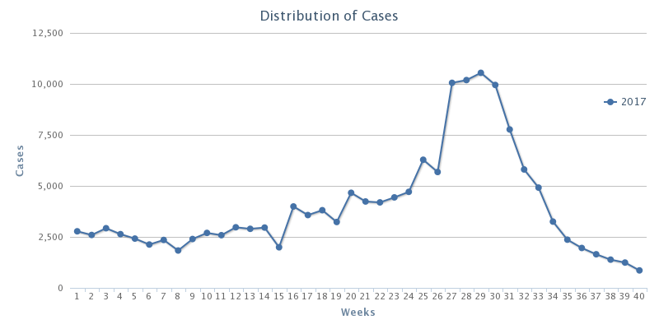

Figure 2 Dengue annual case rate reported weekly in year 2017

A committee has been appointed by the government of Sri Lanka to thoroughly study the dengue epidemic and provide recommendations towards the better control of dengue epidemic. The committee comprised of professionals from several important fields including medicine, healthcare, environmental and higher research institutions. The committee was first appointed in 2001.The final report was produced in year 2005 and handed over to the government of Sri Lanka. This report proposed several action plans which included very important recommendations. Those listed below,

1. To reduce morbidity and mortality due to DF/DHF.
2. To forecast and prevent dengue epidemics.
3. To strengthen liaison with civil society groups, NGO, media and other relevant stakeholders for social mobilization in dengue control.
4. To identify and mobilize resources to carry out research on dengue.
5. To develop and sustain an effective dengue prevention and control program in Sri Lanka.

Among them there is a great attention paid to establish a forecasting model for the dengue epidemic based on the influencing factors. This item in the list of action plan has not been addressed up to now. The effect of the delay of action plan is clearly shown in the dengue trend as shown in Figure 3 and Figure 4. And also it is clearly depicted in the Figure 3 the strong relation that exists between rainfall and reported dengue cases. The higher peaks occur after every monsoon season.

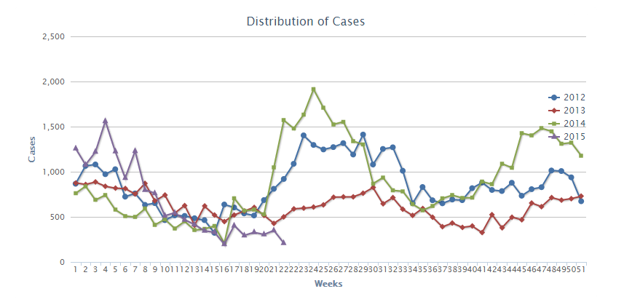

Figure 3 Dengue trend for years 2012-2015

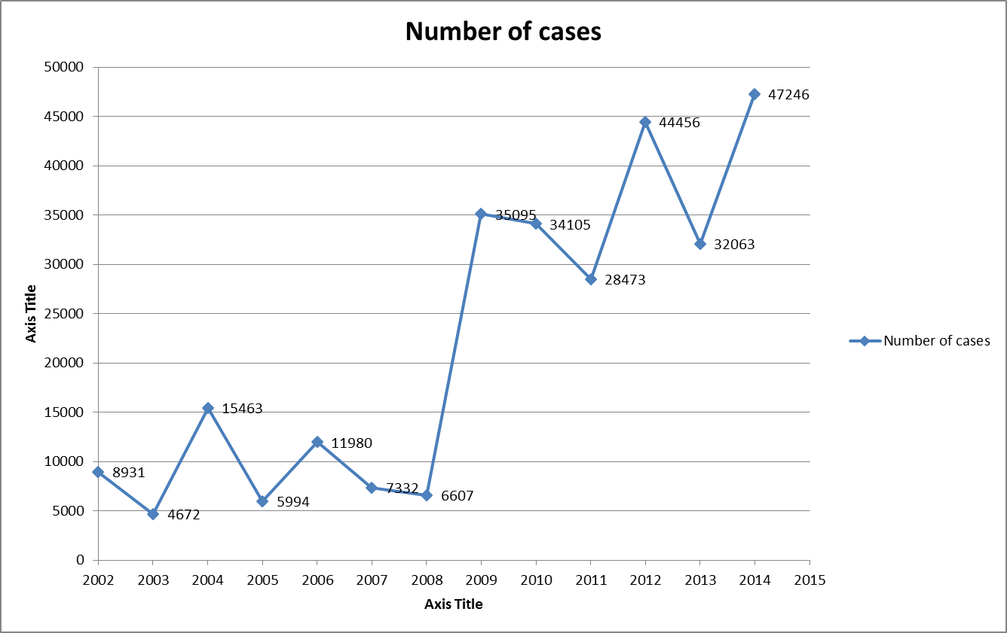

Figure 4 Dengue case trends from 2002 to 2014

It is very crucial to design and develop a dengue epidemic forecasting model as the dengue epidemic is getting worse and fatality of the epidemic is getting increased every year since 2005.

## 2.3 Questions to be addressed

1. What are the factors that positively affect the spread of dengue epidemic?
2. Are there any local factors that are more important when modeling epidemic and missed when considering only global factors?
3. What is the effectiveness of Support Vector Regression (SVR) in prediction when considering global and local factors with both vector and human population considered? What parameter settings give the best fit?
4. How effective it is to use SVR ensemble to deal with multiple independent parameters?
5. Can we improve the result by feeding the SVR with a combination of geographical, socio economic, and weather data?

# CHAPTER 3 Background

## 3.1 The geography of Sri Lanka

Sri Lanka, formerly called Ceylon, is an island in the Indian Ocean, located in Southern Asia. It has 64,740 km² of land and 870 km² of water. Sri Lanka's climate is mainly tropical. There are two main rainfall seasons which are the northeast monsoon (from December to March), and the southwest monsoon (from June to October). Majority of Sri Lanka’s land is flat and approximately at sea level. The highest point is Pidurutalagala which is 2,524.13 m high.

In Sri Lanka, provinces are the first level administrative division. Districts are the second-level administrative divisions, and are included in province. There are 25 districts organized into 9 provinces. Administrative regions are shown in Figure 5.

|  |  |
| --- | --- |
|  |  |
| (a) | (b) |

Figure 5 (a) Provinces (b) Districts of Sri Lanka

## 3.2 Climate of Sri Lanka

### Rainfall

Rainfall in Sri Lanka has multiple origins. Monsoonal, Convectional and expressional rain accounts for a major share of the annual rainfall. The mean annual rainfall varies from under 900mm in the driest parts (southeastern and northwestern) to over 5000mm in the wettest parts (Figure 6).

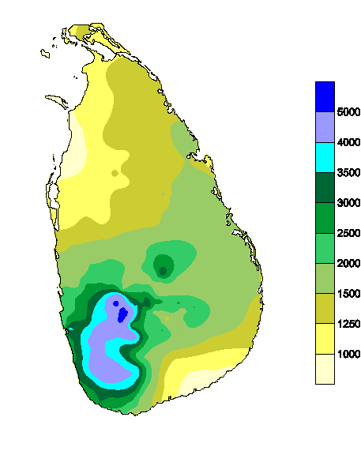

Figure 6 **Annual rainfalls in Sri Lanka (Courtesy: Department of Meteorology Sri Lanka)**

### Temperature

Regional differences observed in air temperature over Sri Lanka are mainly due to altitude, rather than to latitude. The mean monthly temperatures differ slightly depending on the seasonal movement of the sun, with some modified influence caused by rainfall. The mean annual temperature in Sri Lanka manifests largely homogeneous temperatures in the low lands and rapidly decreasing temperatures in the highlands. In the low lands, up to and altitude of 100 m to 150 m, the mean annual temperature various between 26.5 0C to 28.5 0C, with an annual temperature of 27.5 0C. In the highlands, the temperature falls quickly as the altitude increases. The mean annual temperature of Nuwaraeliya, at 1800 m sea level, is 15.9 0C. The coldest month with respect to mean monthly temperature is generally January, and the warmest months are April and August.

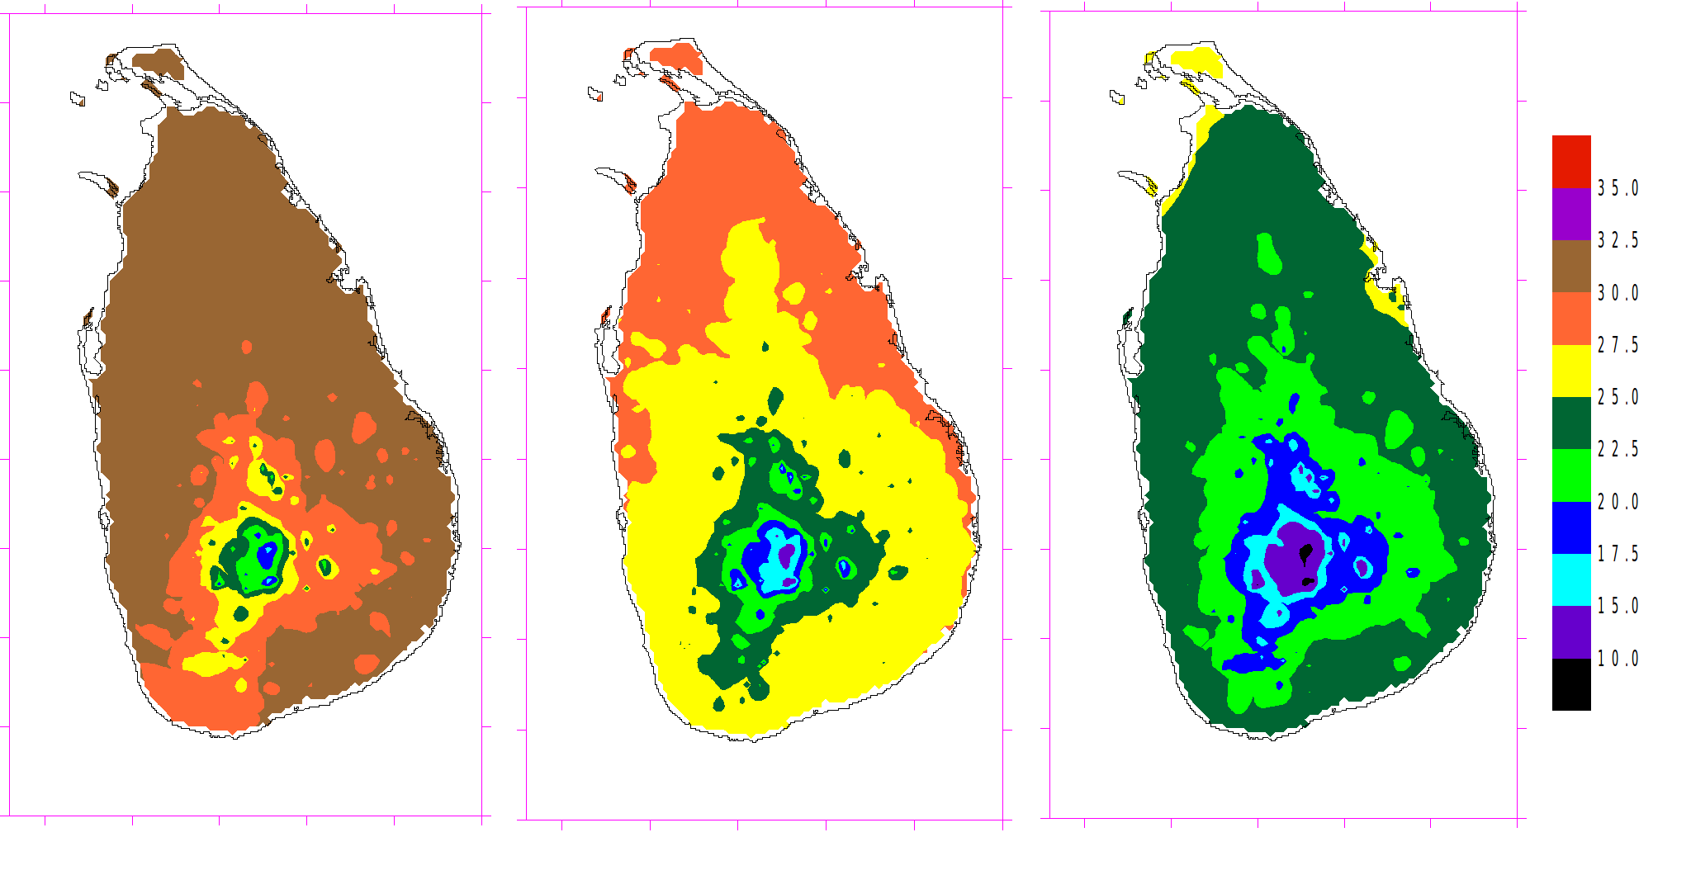

(c)

(b)

(a)

Figure 7 Average temperatures from 1961 to 2015 for (a) April (b) August and (c) January **(Courtesy: Department of Meteorology Sri Lanka)**

### Climate Seasons

The Climate of Sri Lanka is dominated by the above mentioned topographical features of the country and the Southwest and Northeast monsoons regional scale wind regimes. The Climate experienced during 12 months period in Sri Lanka can be characterized in to 4 climate seasons as follows.

* First Inter-monsoon Season - March - April
* Southwest monsoon season - May - September
* Second Inter-monsoon season - October - November
* Northeast Monsoon season - December – February

*First Inter-monsoon Season (March - April)*

The distribution of rainfall during this period shows that the entire South-western sector at the hill country receiving 250 mm of rainfall, with localize area on the South-western slops experiencing rainfall in excess of 700 mm (Keragala 771 mm). Over most parts of the island, the amount of rainfall various between 100 and 250 mm, the notable exception being the Northern Jaffna Peninsula (Jaffna- 78 mm, Elephant pass- 83 mm).

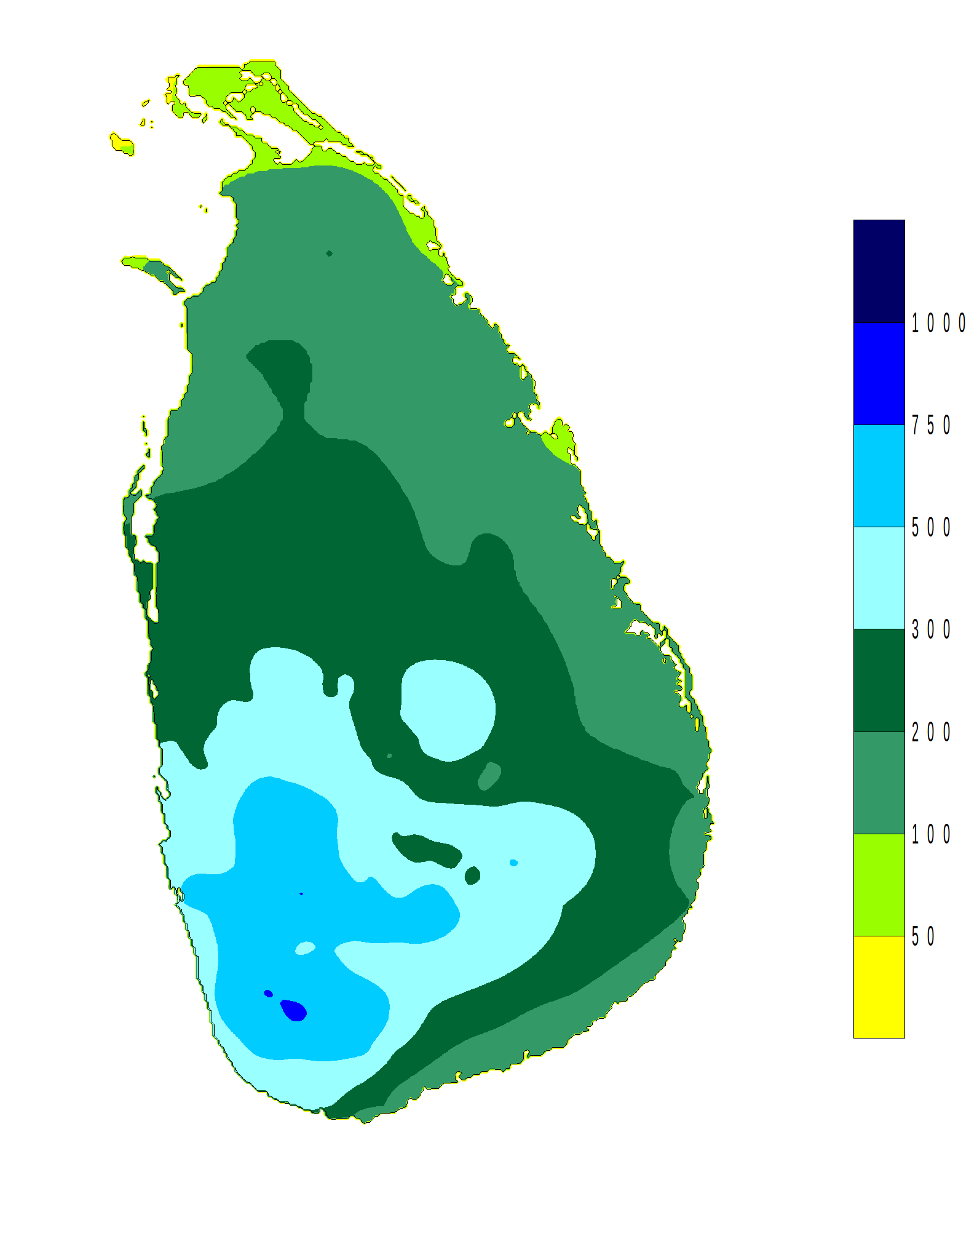

Figure 8 distribution of rainfall in First Inter-monsoon Season**(Courtesy: Department of Meteorology Sri Lanka)**

*Southwest -monsoon Season (May - September)*

Southwest monsoon rains are experience at any times of the day and night, some times intermittently mainly in the Southwestern part of the country. Amount of rainfall during this season varies from about 100 mm to over 3000 mm. The highest rainfall received in the mid-elevations of the western slops (Ginigathhena- 3267 mm, Watawala- 3252 mm, Norton- 3121 mm). Rainfall decreases rapidly from these maximum regions towards the higher elevation, in Nuwaraeliya drops to 853 mm.   The variation towards the Southwestern coastal area is less rapid, with the Southwestern coastal belt experiencing between 1000 mm to 1600 mm of rain during this 5 month long period. Lowest figures are recorded from Northern and Southeastern regions.

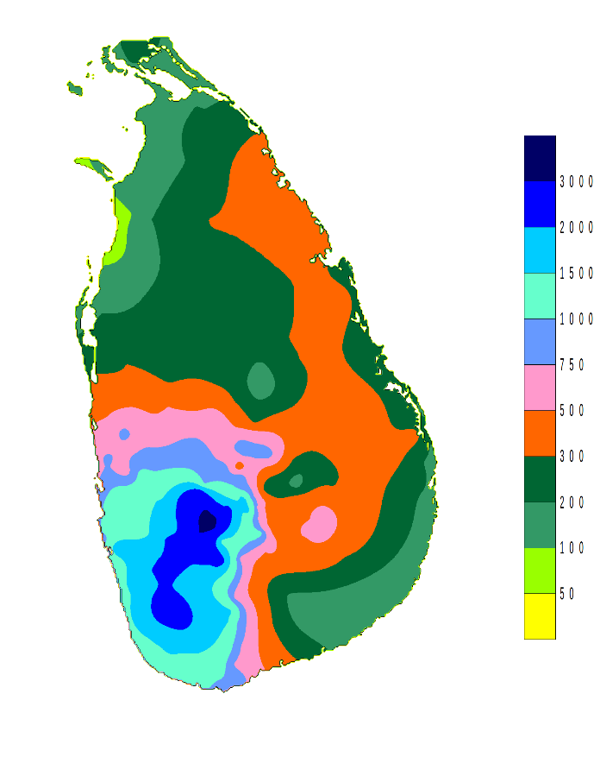

Figure 9 rainfall distributions for Southwest -monsoon Season**(Courtesy: Department of Meteorology Sri Lanka)**

*Second Inter-monsoon Season (October-November)*

The thunderstorm-type of rain, particularly during the afternoon or evening, is the typical climate during this season. Under such conditions, the whole country experiences strong winds with wide spread rain. The second Inter-monsoon period of October – November is the period with the most evenly balanced distribution of rainfall over Sri Lanka. Almost the entire island receives in excess of 400 mm of rain during this season, with the Southwestern slops receiving higher rainfall in the range 750mm to 1200 mm.

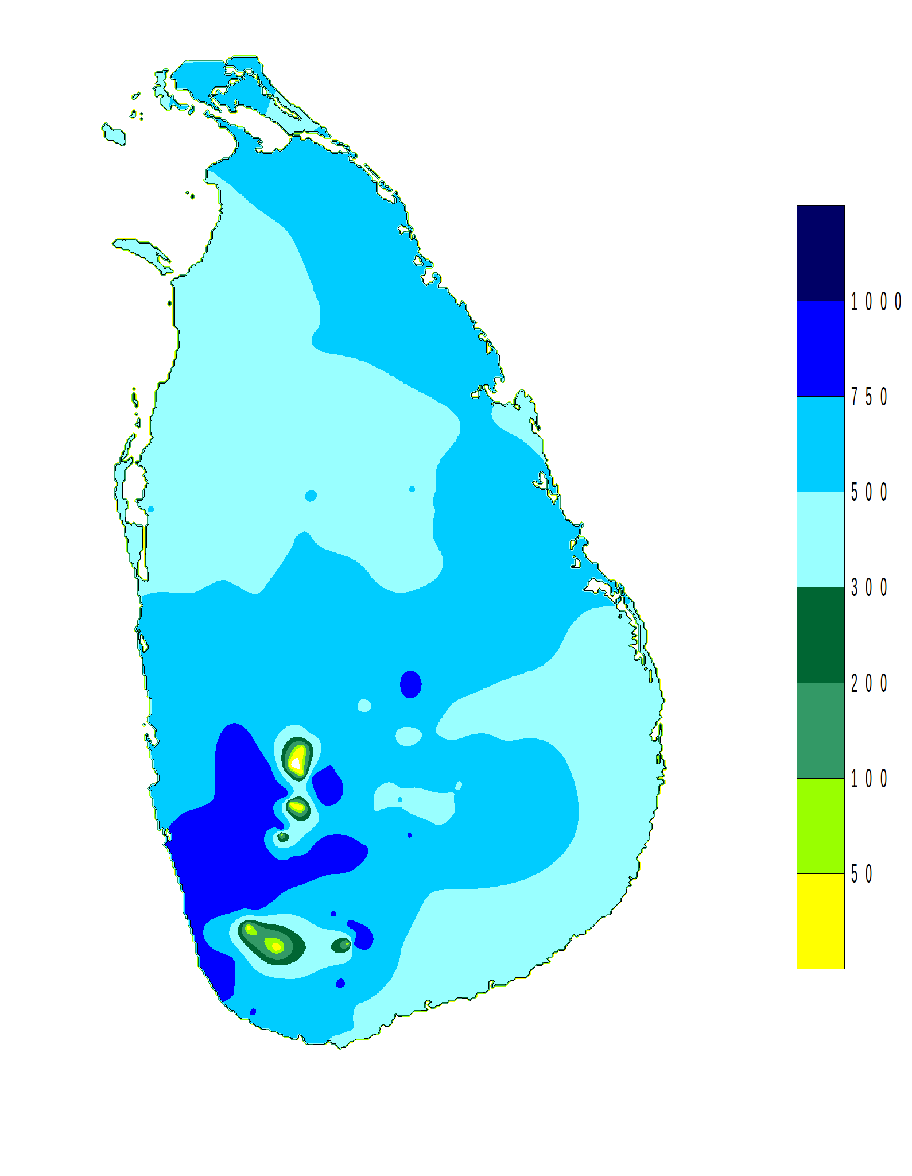

Figure 10 rainfall distributions for Second Inter-monsoon Season**(Courtesy: Department of Meteorology Sri Lanka)**

*Northeast -monsoon Season (December - February)*

During this period, the highest rainfall figures are recorded in the North, Eastern slopes of the hill country and the Eastern slopes of the Knuckles/Rangala range. The maximum rainfall is experience at Kobonella estate (1281 mm), and the minimum is in the Western coastal area around Puttalam (Chilaw- 177 mm) during this period.

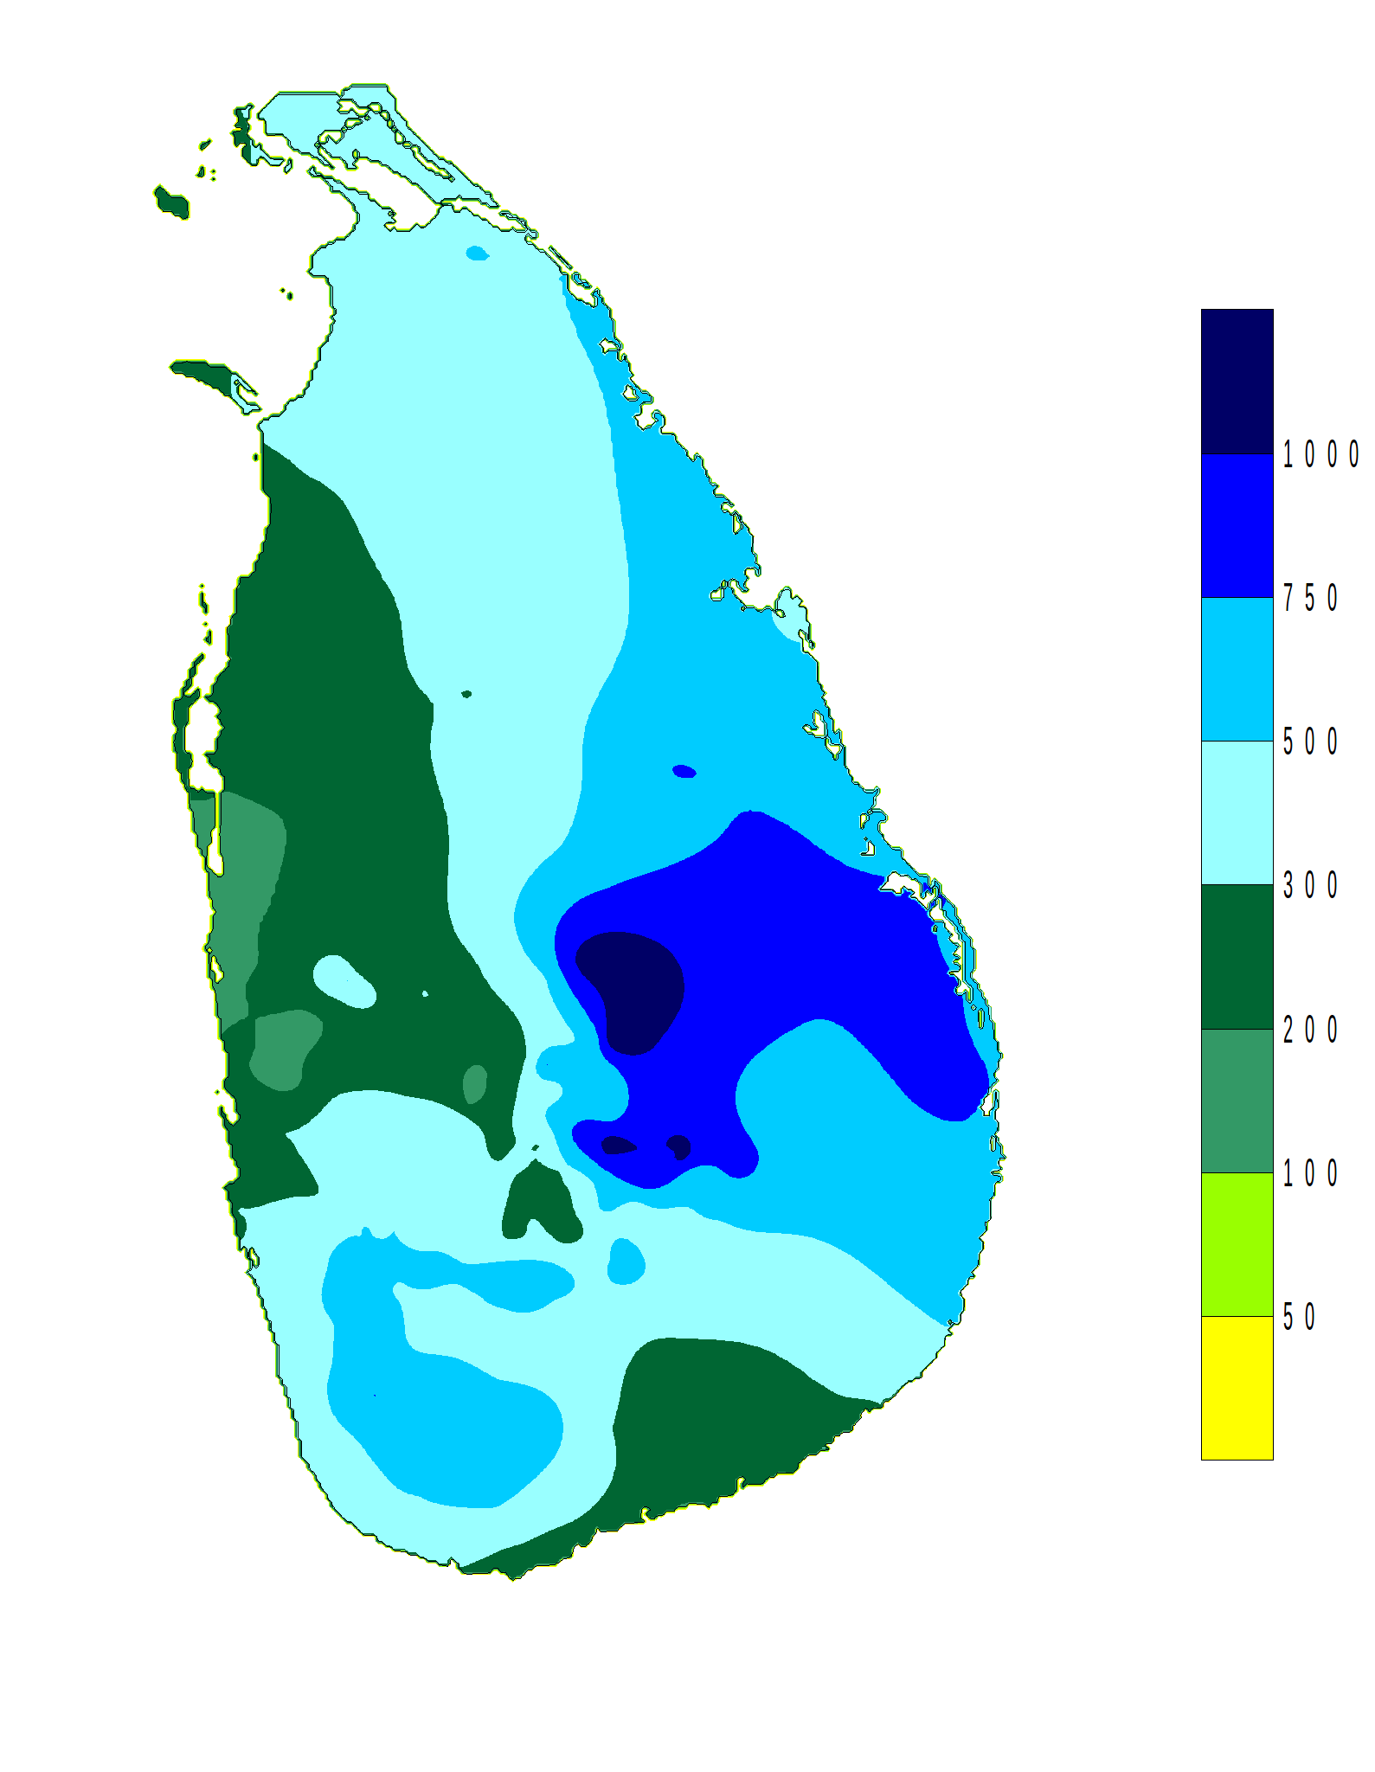

Figure 11 rainfall distributions for Northeast -monsoon Season**(Courtesy: Department of Meteorology Sri Lanka)**

## 3.3 The dengue epidemic of Sri Lanka

Dengue viruses (DENV) are mosquito-borne flaviviruses that have plagued humans for centuries. Urbanization and human population growth in the tropical regions of the world have produced favorable conditions for DENV transmission. Moreover, changes due to urbanization and human population growth have led to the current global dengue pandemic, characterized by a dramatic increase in DENV infections and an expanding geographic distribution of both DENV and the mosquito vectors,[1](http://www.sciencedirect.com/science/article/pii/S1201971213003421#bib0005)*Aedes aegypti* and*Aedes albopictus*, which transmit DENV among humans.

In Sri Lanka, 48 Aedes species belonging to 11 subgenera have been reported to date. The subgenera are *Aedimorphus, Cancraedes, Christophersiomyia, Diceromyia, Finlaya, Mucidus, Neomelaniconion, Paraedes, Rhinoskusea, Stegomyia, and Verrallina.* The established DENV vectors *A. aegypti* and *A. albopictus* belong to the subgenus *Stegomyia*. However, nothing is known about the role of the remaining 46 *Aedes* species in DENV carriage and transmission, an area that might shed some light on how DENV survive the intra-epidemic periods.

Sri Lanka has been affected by dengue fever (DF)/dengue hemorrhagic fever (DHF) epidemics for over two decades. DENV infections have been endemic in Sri Lanka since the mid-1960s. DF was serologically confirmed in the island in 1962. The presence of DF in all of the major towns situated below 1200 m elevation was confirmed in 1966 and in 1976–1978.

In Sri Lanka, DF control efforts have been targeted at the disease and vector, including laboratory surveillance for DENV infections in patients and vectors, vector control, social mobilization, clinical management of DF/DHF patients, and the emergency response during outbreaks in terms of accelerated vector control and public awareness through the media. A national-level multidisciplinary task force on DF/DHF has been established to govern the DF/DHF control activities. Furthermore, there are provincial and district-level DF/DHF control activities in place. Training clinicians on clinical management has been carried out continually to bring the DF/DHF mortality to zero, or to a minimum level. It is hoped that with the implementation of collective control programs in collaboration with other governmental and non-governmental organizations, with maximum cooperation from the community, the morbidity and mortality of DF/DHF will be reduced soon.

## 3.4 The virus

DENV is a flavivirus transmitted by *Aedes* aegypti mosquitoes. There are four antigenically distinct DENV serotypes, DENV 1–4. Infection with a single DENV serotype leads to long-term protective immunity against that serotype, but not against the other serotypes.  Thus, prior infection with a single serotype of DENV only provides a homotypic protection. The four serotypes of DENV have been co-circulating in Sri Lanka for more than three decades and their distribution has not changed drastically in the last 30 years. Although the Sri Lankan population had been exposed to DENV for a long time, the severe forms of DENV infection (DHF and dengue shock syndrome (DSS)) were rare before 1989. Studies have shown the existence of more than one DENV serotype in many parts of the country. There was an island-wide epidemic of DF associated with DENV serotypes 1 and 2 from 1965 to 1968. This epidemic caused 51 DHF cases and 15 deaths.[5](http://www.sciencedirect.com/science/article/pii/S1201971213003421#bib0025) DENV-1 and DENV-2 were isolated from the outbreaks in 1965 and 1966.

A study conducted using mosquito pools in the Western and North-Western provinces of Sri Lanka, including the districts of Colombo, Gampaha, and Kurunegala, has indicated the circulation of multiple DENV serotypes within close proximity to each other. Mosquito pools from Kurunegala district were positive for both DENV-2 and DENV-4, while mosquito pools from Gampaha and Colombo districts had DENV-2 and DENV-4. Higher numbers of positive pools of DENV-1 and DENV-4 have been reported in Kurunegala.

## 3.5 REPLAN framework

RE-PLAN is a computational framework developed to create, analyze and optimize emergency response plans for public health emergencies. Specially, RE-PLAN facilitates the placement of PODs across the region of interest and establishes the geographic region that is being served by each POD. POD locations are selected to minimize the distance that the public has to travel to receive emergency services. Population distribution and geospatial data of the region are utilized for the purpose of response plan creation. Data pertaining to the infrastructure of the region, such as the road network, are utilized in analyzing the effectiveness of the resulting response plan. Specific methods have been developed as part of the RE-PLAN framework to enable creation, analysis and optimization of response plans for different scenarios [2].

A response plan developed in RE-PLAN consists of a set of PODs and their respective service areas. Each POD is a location in the region of interest defined by its geographic coordinates and attributes such as the number of service booths that the facility may accommodate. A service area of a POD is a portion of the region of interest that is serviced by the POD. Service areas consist of groups of contiguous population blocks, which are geographic entities such as represented by polygons with associated population counts. Population blocks, for instance, can be geographic entities such as census blocks or block groups used by the United States Census Bureau to represent populations. RE-PLAN facilitates response plan creation by either establishing the service areas for a set or subset of user-supplied PODs or by recommending a partitioning of the region into service areas and selecting available POD locations for each of the service areas. Methods which determine the service areas for a given set of POD locations are referred to as constrained methods. Unconstrained methods partition the region into service areas and map suitable PODs to these service areas.

The response plans created using either constrained or unconstrained methods are examined for their feasibility with respect to mandated guidelines. The feasibility of a response plan is determined subject to its performance with respect to mandated time constraints and infrastructural limitations. In general, a response plan is said to be feasible if the following conditions hold:

* All PODs that are part of the plan are capable of serving the populations of their respective service areas within a mandated time frame.
* The burden on roads or other public infrastructure that are used during the emergency is within acceptable limits.
* The infrastructure at a POD facility can accommodate the demand exerted by the population of the service area.

POD analysis tools such as the traffic analyzer or the facility analyzer, which is a part of the RE-PLAN framework, can be used to determine the feasibility of a response plan. In this proposal we have adopted a simpler form of response plan feasibility, focusing only on a POD's ability to serve the population of its service area in a mandated time frame. The main components of the RE-PLAN framework are the RE-PLAN client and the RE-PLAN spatial database. The client can be broadly structured into the following components: plan designer, logistics calculator and plan analyzer. The plan designer provides an interface for users to specify the region of interest, select POD locations and adjust POD configurations. Constrained and unconstrained methods to create and optimize response plans based on selected POD locations or service areas can be invoked through the plan designer. Once a response plan has been created, the logistics calculator incorporates data pertaining to the infrastructure of the region, such as road capacities or public transportation, into the response plan to facilitate analysis of the plan. Plan analysis tools provide methods to analyze the feasibility of response plans with respect to constraints such as time, POD capacity and infrastructural limitations of the region. The facility analyzer examines the performance of each POD facility with respect to the POD's capacity and population of its service area. RE-PLAN is written in Java and uses a PostgreSQL database with PostGIS capabilities to handle spatial data and operations. An overview of RE-PLAN's architecture has been described [2].

## 3.6 Moderate Resolution Imaging Spectroradiometer (MODIS) Data Grid

Monitoring of land cover and land use is an important element of the NASA Earth Science Enterprise. Moderate resolution remote sensing provides a means for quantifying land surface characteristics such as surface temperature. High quality, consistent and well-calibrated satellite measurements are needed if we are to detect and monitor changes and trends in these variables. The Moderate Resolution Imaging Spectroradiometer, or MODIS, sensor resides aboard the Terra and Aqua platforms, offering a view the Earth's surface every 1-2 days. The MODIS sensor collects data within 36 spectral bands, ranging in wavelengths from 0.4 µm to 14.4 µm and provides us with imagery at a nominal resolution of 250 m at nadir for two bands, 500 m resolution for 5 bands, and the remaining 29 bands at 1 km.

The MODIS land products are produced at 4 resolutions (250m, 500m, 1km, and 0.05 degree), and in 3 projections (Sinusoidal, Lambert Azimuthal Equal-Area, and Geographic). The simple Geographic lat/lon projection is only used for the coarsest resolution grid, produced at 0.05 km (~ 5.5 km), which is referred to as the Climate Modeling Grid (CMG). In order to maintain reasonable file sizes for the other higher resolution MODIS land data products, each projection is divided up into a tiled grid. The land products are thus produced and distributed in adjacent non-overlapping tiles that are approximately 10 degrees square (at the equator). Most of the higher resolution MODIS land products are produced in the Sinusoidal tile grid.

## 3.7 Sinusoidal Tile Grid

There are 460 non-fill tiles; tiles are 10 degrees by 10 degrees at the equator. The tile coordinate system starts at (0, 0) (horizontal tile number, vertical tile number) in the upper left corner and proceeds right (horizontal) and downward (vertical). The tile in the bottom right corner is (35, 17). The arrangement of tiles is shown in Figure 12.

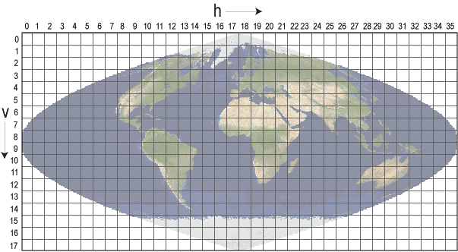

Figure 12 MODIS data grid arrangement

In this study, v8h25 and v8h26 tiles in which Sri Lanka included, is used to obtained the temperature and rainfall data. As the grid spans beyond the boundary of Sri Lanka, it is required to perform spatial intersection between grid data and the boundary of Sri Lanka. To obtain the data for each administrative unit, it is required to perform the same operation between grid data and the administrative region boundaries. Data is obtained as HDF files and converted back into geotiff file format using MRT tool. The converted two tiles can be shown in Figure 13.

|  |  |
| --- | --- |
| tile1.png | *tile2.png* |
| (a) | (b) |

Figure 13 (a) tile v8h25 and (b) tile v8h26 showing surface temperature

# CHAPTER 4 Related works

## 4.1 Dengue Epidemic

Increases in disease transmission and the frequency of epidemics have also been the result of circulation of multiple serotypes in Asia [8]. Nearly 2.5 billion people around the world living in dengue endemic countries with a risk of contracting DF/DHF, nearly half live in 10 countries of the Southeast Asia region. Nearly 75% of the current global disease burden due to DF/ DHF is reported in the Southeast Asia region together with Western Pacific region. In 2002, DF/DHF was ranked as the third most common noticeable disease in Sri Lanka (first and second were malaria and tuberculosis) [9, 10]. In recent years, deaths due to DF/DHF have been greater than those due to malaria, and DF/DHF is becoming the number one killer mosquito-borne infection in Sri Lanka [9]. At present, DF and DHF are prevalent in many urban and semi-urban areas of Sri Lanka with seasonal and periodic epidemics occurring regularly in the island [5]. In recent decades a higher incidence of DF/DHF has occurred in the districts of Colombo, Gampaha, Kalutara, Kurunegala, Kegalle, Ratnapura, and Kandy [11] from 2000 to 2008, the reported number of suspected and serologically positive DF/DHF cases varied from 4749 to 15 643, involving 25–88 deaths, with a major epidemic in 2004 [6]. DF/ DHF have become endemic in northern and eastern Sri Lanka, with a high incidence in the capital cities of the northern and eastern provinces of the island, Jaffna and Batticaloa, respectively [12].

There is a significant relation of the dengue epidemic to the age group of the population. In many age groups, males have predominantly been affected. According to a regional study done by the World Health Organization (WHO) in Sri Lanka based on reported cases from 1996 to 2005, there were consistently and significantly larger proportions of males with DF/DHF in those aged 15 years. This male preponderance was reported in every province of the country. Among those aged 1–4 and 5–14 years, there were significantly fewer male cases than expected, although there was some annual variation [13]. The highest incidence occurred in the 5–9 years age-group [3]. Before 2000, one large peak of DF/DHF cases was observed in children and a few cases were observed in adults. After 2000, two reported DF/DHF peaks were observed in children and young adults. Moreover, the mean age of reported DF/DHF cases was shown to have increased from 15 years in 1996 to 25 years in 2006 [4].

Climate change such as temperature, rainfall, and humidity can expand the geographical range of vector mosquitoes. And also it can extend the disease transmission season, shorten the gonotrophic cycle, and reduce the time taken for ingested viruses to develop to infective stages in mosquitoes, thereby increasing the propagation rates of arboviral diseases transmitted by*A. aegypti and A. albopictus*[7, 14, 15, and 16]. In addition, these works clearly pointed out that there is a strong positive correlation between rainfall and the dengue cases reported. Two DF/DHF peaks occur annually in association with the monsoon rains, when the densities of two mosquito vectors (*A. aegypti and A. albopictus*) are high in Sri Lanka. Generally, the first peak occurs in June/July, coinciding with the south-western monsoon that commences in late April. The second peak, comparatively a smaller one, usually occurs at the end of the year and is associated with the north-eastern monsoon rains that prevail from October to December [3].

Temperature is another important factor controlling the seasonality of DF/DHF outbreaks in sub-tropical or temperate regions. It influences vector distribution, the blood feeding activity of the vector, the extrinsic incubation period, and adult longevity. *A. aegypti* has been shown to transmit DENV when the temperature is above 20 8C but not less than 16 8C. A positive correlation has been shown between the temperature and the female vector abundance. In addition, high temperatures may increase the frequency of blood feeding due to a rapid reduction in energy reserves [17]. It is expected that global warming may further facilitate the expanded distribution of DENV mosquito vectors in temperate regions such as northern parts of North America and Europe [18]. This concern has become a far more serious matter with the expanding distribution of *A. albopictus* [19]. Altitude also plays a vital role in limiting the distribution of A. aegypti. In India, A. aegypti breeding sites range from sea level to 1000 m above sea level. Lower elevations (less than 500 m) have moderate to heavy mosquito populations, while mountainous areas (over 500 m) have low populations [20].

There is couple of researches conducted to study the control measures of the dengue epidemic in Sri Lanka. These studies have revealed couple of strategies to be used in controlling the epidemic. A study conducted in the Kandy District of Sri Lanka showed that the mechanical and biological measures alone are not sufficient to prevent *Aedes* breeding. The prevention of A. aegypti and A. albopictus breeding in water storage containers would greatly help to control DF/DHF. Therefore, DF/DHF control programs should pay more attention to the control of Aedes breeding in domestic water storage containers [5]. More importantly, public education on preventing dengue epidemic will greatly reduce the mosquito breeding sites and hence will be very effective in dengue mitigation [21, 22]. This will call for a system to integrate all these findings and develop a methodology as proposed in this proposal to effectively deal with dengue epidemic in Sri Lanka. We propose to study all the influencing factors and use them in forecasting/predicting system to clearly identify the high risk areas. And also the proposed system is capable of estimating the casualties of the upcoming dengue epidemic hence can be better prepared for the event. This information is in great help in educating general public and putting controlling measures into action. And also the proposed system consists of a web base client to effectively communicate the findings of the proposed method among health professional and hence accelerate the information flow.

## 4.2 Forecasting /Prediction

*GIS and statistical models*

The authors of [23] and [24] studied the prediction of dengue outbreak in Sarawak and Johor respectively by using statistical models. The work presented in [23] analyzes the interaction between environmental, entomological, socio-demographic factors. This study also used GIS technology to generate geographic and environmental data on *Aedes albopictus* and dengue transmission. A total of 32,838 *Aedes albopictus* eggs were collected in 56 days of trapping. Cluster sampling was also done to determine whether any of the risk factors (entomological or geographical) were influenced by geographical location. The data collected were analyzed using SPSS version 10.01. Descriptive analysis using frequency, means, and median were used. To determine the association between variables and dengue cases reported, and to describe the differences between the two clusters of villages, two-sample t-test, and Pearson's Chi-Square were used. Accurate maps were produced with overlay and density function, which facilitates the map visualization and report generating phases. This study also highlights the use of differential Global Positioning System in mapping sites of 1m accuracy. Analysis of the data revealed there are significant differences in clusters of villages attributable to container density, house density, and distance of the house from the main road, and number of Ae. albopictus eggs from ovitraps set indoor, outdoor and in dumping sites (Person's Chi-Square = 6.111, df = 1, p < 0.01). Further analysis using t-test showed that house density, container density, indoor mosquitoes egg count, outdoor mosquitoes egg count, and dumping sites mosquitoes egg count were higher at the roadside villages compared to border villages. A number of potential risk factors including those generated from GIS were investigated. None of the factors investigated in this study were associated with the dengue cases reported. The work presented in [24] takes into consideration various environmental factors such as rainfall, temperature, living conditions, demography structure domestic waste management and population distribution in determining the mosquito survival and reproduction. A geostatistical modeling, analysis and mapping approach has been utilized in this research to understand the correlation between dengue fever prevalence, population distribution and meteorological factor, and the characteristics of space-time clusters in the Johor State. By supplementing GIS with geostatistical analysis and space-time permutation scan statistic tools, the spatial variation of dengue incidence can be mapped. Geographical weighted regression (GWR) analysis has revealed a strong (R2= 0.87) positive spatial association between dengue fever prevalence and population distribution in the Johor State. Vaidya A. at el. [61] introduces a mathematical, compartmental model to forecast the population dynamics of a mosquito and its life cycle in relation to seasonal variations of temperature and rainfall. Populations within the compartments were expressed in the form of a system of coupled differential equations, which describe changes in the mosquito population through processes of maturation and mortality. Maturation and mortality rates at various temperatures were estimated by regressing published data. The correlated rates with temperature were used in the model to numerically solve the differential equations.

*Neural Network*

The work presented by authors in [32] had predicted the dengue confirmed cases by using the neural network. The used factors were average temperature, average humidity, total rainfall and the dengue confirmed case number. The set of data recorded consists of 14,209 dengue reported confirmed-cases have been analyzed by using the ANNs. It has been produced very encouraging results in this study. The results showed that the four important features namely mean temperature, mean relative humidity, total rainfall and the total number of dengue confirmed-cases were very effective in predicting the number of dengue confirmed-cases. The ANNs have been found to be very effective processing systems for modelling and simulation in the dengue confirmed-cases data assessments. The authors claim that the proposed prediction model can be used world-wide and in any period of time since the approach does not use time information in building it. The authors proposed an automatic prediction system of Dengue Hemorrhagic Fever outbreak by using entropy and ANN [25]. In this system, the information extraction is preprocessed prior to the prediction in order to reduce data redundancy and retain only those relevant data. First, the external factors such as temperature, relative humidity, and rainfall are considered during the information extraction. Then, a supervised neural network is deployed to predict the possible risk of Dengue Hemorrhagic Fever outbreak. To evaluate the performance of proposed system, the experiments based on the condition of weather data and Dengue Hemorrhagic Fever cases from January 1999 until December 2007 were conducted. Authors claim 85.92% accuracy compared to the actual data.

*Cellular Automata*

Cellular automata models began from the concept of John von Neumann to make the machine copies itself. Cellular means "consist of cells". Cellular automata can be multidimensional. If there are two dimensions, it resembles a checkerboard. Each cell has some adjacent cells and called "Neighborhood". Changing the status of a cell in one time step depends on local rules. The local rules may be the probability [35]. This research uses Moore neighborhood with radius=1 and using the probability in changing status. The main epidemic models are used with a cellular automaton model are SIR and SEIR model. For SIR model ,each cell has only one status in one time step such as 'S' represents susceptible , 'I' represents infected and is able to transmit the disease to the others , 'R' represents recovered. Some diseases have a latent period, a status for this period is 'E' and is called SEIR model [34]. An outbreak of dengue fever is characterized by a SEIR model. Some people are not sick when exposed to the dengue virus. The patient will have an incubation period of about a week after exposure virus and before symptoms to appear. The authors created a model of HBV infection by using cellular automaton [31]. The CA lattice size was 300x5000. The status of a cell in lattice might be "susceptible”, "infected”, "core" or "immune". The local rules were the probability. The work presented in [33] had created a time series model to predict the number of patients with Chickenpox by using probabilistic Cellular Automata. Chromosome of genetic algorithm consists of the state changing probability. Experimental results showed that the bigger number of cells in lattice is better than fewer numbers of cells. The experimental weakness is the forecasting did not use any factor. The proposed model presented in [30] takes a number of people in each status of an epidemic model called SIER into consideration. In this respect, CA take a Genetic Algorithm (GA) to generate the factor weight chromosomes and ANN to determine the probability of state transition 'S' to 'E' at time step t (Pt(s, e)). In addition, other related probabilities are obtained by expert knowledge; P(e, i) = 0.15 and P(i, s)=0.001. P(r, s) is determined by GA. These probabilities were used to calculate the cell number of each state at the next time step of GA. GA compute the fitness for one time step and repeat every time step finally to compute RMSE. For performance evaluation, 32 factors of dengue causes are used in the model. The dataset collected during 2005 to 2011 consisting of 359 weeks in which 287 and 72 are used to train and test the model, respectively. Authors claim with the results obtained that their method outperforms the artificial neural network approaches.

*Support Vector Machine*

Support vector machine is used in various fields to perform pattern recognition successfully. These areas include face detection/recognition, object detection, image retrieval, information retrieval, speech recognition, and prediction/forecasting. SVM is also used as a regression model in which a value for the dependent parameter is given instead of the class of the parameter. The aim of many nonlinear forecasting methods [26, 27, 28, and 29] is to predict next points of time series. Tay and Cao [29] proposed C-ascending SVMs by increasing the value of C, the relative importance of the empirical risk with respect to the growth of regularization term. This idea was based on the assumption that it was better to give more weights on recent data than distant data. Their results showed that C-ascending SVMs gave better performance than standard SVM in financial time series forecasting. Fan et al. [28] had adopted SVM approach to the problem of predicting corporate distress from financial statements. For this problem, the choice of input variables (financial indicators) affects the performance of the system. This paper had suggested selecting suitable input variables that maximize the distance of vectors between different classes, and minimize the distance within the same class. Euclidean distance based input selection provided a choice of variables that tends to discriminate within the SVM kernel used.

In this work we use Support Vector Regression for the prediction/forecasting of the dengue cases in the upcoming epidemic. The main rationale behind the selection of SVM is that it can be easily adopted in the web server. This will enable us to integrate the prediction model in the web user interface.

## 4.3 Response Planning

Dispensing treatments to the public during an emergency is an important task. There are numerous work have been done on various aspects of response planning. Every plan must deploy methods to distribute supplies and dispense medication to the affected population within a specified time frame [36]. There are other important factors such as vulnerabilities of the population that must be taken into consideration when developing a response plan. Each of these factors is taken into account separately in different works. Routing and scheduling the distribution of supplies have been addressed in different ways, and management of treatment facilities has been studied. Different strategies to distribute medication among the facilities have been introduced in the research work [37]. The challenge of distributing medications and treatment supplies to each local agency is a challenge. The concept of Point Of Dispense (PODs) was introduced by the Center for Disease Control (CDC). PODs strategy is been recognized by the authorities as an effective method of planning an emergency. The CDC maintains a warehouse of treatment supplies and medications and delivers them in accordance with the demand to the local authorities. It is the responsibility of each local authority to develop their own response plan adheres to the guidelines setup by the CDC [36]. The PODs concept is well utilized in the RE-PLAN framework, developed at the Center for Computational Epidemiology and Response Analysis (CeCERA) [38]. The framework is capable of producing an effective response plan based on PODs placement where necessary. There are couple of different PODs placement methods introduced in the framework. Each of which is suitable for different scenarios. And hence, the RE-PLAN is a better candidate for the proposed work to make use of by adapting the functionality.

The work presented in [39] has pointed out the additional strain imposed when dealing with mass events involving mass number of people. Public health and policy studies stressed the mandating the managing of limited resources during an emergency [40]. Ethic in allocating resources during a mass casualty event is presented in [36] [41].

The spatial data of the region is a critical component in response planning. This will allow localization of data and provide a visual feedback to the plan designer. The spatial data may include population distribution and road infrastructure, and census data with arbitrary census blocks. For an effective management and manipulation of spatial data, Geographical Information System (GIS) is needed. Integration of GIS data and usage of spatial tools in response planning are widely studied and recommended by various studies [42]. RealOpt [43] proposed a simulation and decision support system created to support planning, designing and placing large-scale emergency dispensing clinics for emergency response. The Centers for Disease Control and Prevention created BioSense, a surveillance system [44], is targeting at early detection of biological emergency events. Coombes [45] and Schneider et al [46] proposed several methods of defining boundaries for the response planning area. The authors proposed algorithms to solve problems associated with discrete and continuous facility PODs allocation [47, 48, 49, 50, 51 and 52]. RE-PLAN framework provides methods to integrate spatial, population and infrastructural data and design and analyze response plans by means of spatial partitioning algorithms and analysis techniques.

By taking into account all the literature and goals of our proposed works, we move forward with geographically weighted regression in the first phase to analyze the dengue epidemic to identify the main influencing actors. And for the second phase, we deploy a support vector regression to forecast/predict the upcoming dengue epidemic and its severity in each administrative unit. Finally, we use RE-PLAN framework and build the online system to be used in collaborative response planning and public education.

We propose our solution to analyze and predict the dengue epidemic with a trained model which takes into consideration many social economic and geographical factors that positively affect the spread of the epidemic. The main simulating factor for the proposed work is that previous works do not take into consideration the differences of the administrative regions of Sri Lanka. Each province has its own geographical and social economical characteristics and can be different from each other. Assuming all the units are homogeneous may result in a biased conclusion. We need to overcome this shortcoming with the introduction of local characteristics in the model that are specific for each administrative unit.

**3 Materials and Methods**

**3.1 Data Gathering**

The number of dengue cases reported depends on various factors such as rainfall, temperature, population density, waste management efficiency, land use, and water body management etc. In this study, only rainfall, temperature, and population densities are considered. These factors are gathered from various sources based on the availability. The following sections explain our strategies of obtaining each factor.

**Rainfall data.** Rainfall data was obtained from Global Rainfall Map in Near Real Time (GSMaP_NRT) distributed from JAXA Global Rainfall Watch, which was developed based on activities of theGSMaP (Global Satellite Mapping of Precipitation) project. The GSMaP project is promoted for the study"Production of a high-precision, high-resolution global precipitation map using satellite data," sponsored by Core Research for Evolutional Science and Technology (CREST) of the Japan Science and Technology Agency (JST) [14]. GSMaP_NRT repository provides hourly rain rate data in 0.1 degree resolution (10km at the equator). Repository divides the globe into 15 distinct regions as shown in Fig. 1and provides rainfall data separately for each region as Comma Separated Values (CSV) files.Registered users get free access to the repository. The users can get data using an FTP client that is connected to the repository using credential provided by the repository management. Thailand is included in 02_AsiaSE area. Table 1 lists location specific information for each Asian region. For the model training, data from five consecutive years was used.

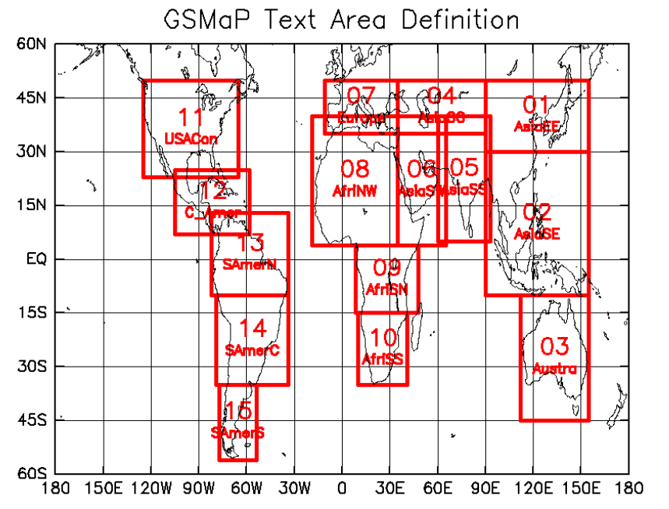

**Fig. 1.** Definition of text areas of JAXA data repository for text data [14]

**Table 1.** GSMap text area declaration for Asian region [14]

|  |  |  |  |  |  |
| --- | --- | --- | --- | --- | --- |
| **Area name** | **Lon**  **(W)** | **Lon (E)** | **Lat (S)** | **Lat (N)** | **Description** |
| 01_AsiaEE | 90 | 155 | 30 | 50 | East Asia |
| 02_AsiaSE | 90 | 155 | -10 | 30 | South East Asia |
| 04_AsiaCC | 35 | 90 | 35 | 50 | Central Asia |
| 05_AsiaSS | 60 | 93 | 5 | 40 | South Asia |
| 06_AsiaSW | 35 | 65 | 4 | 40 | Arabian Peninsula and East Africa |

**Temperature data.** Temperature data was obtained from Thai Meteorological Department (TMD). Average temperature value for each month for each district was used in the training. Time span of temperature data is five consecutive years.

**Population data and dengue case data.** Population and dengue case data for each district for five consecutive years were obtained. Dengue case data is given in three groups which are Dengue Hemorrhagic Fever (DHF), Dengue Fever (DF) and Dengue Shock Syndrome (DSS). I combine all three categories to form a single entity and used in model training as dengue cases. Dengue case data was obtained from Department of Disease Control, Ministry of Health.

**3.2 Data Processing**

**Extracting relevant data and alignment of time resolution.** GSMaP_NRT region 02_AsiaSE covers a larger area than Thailand geographical region (Figure 1). This results in large amount of non-related data being loaded into the spatial database making it heavy for fast computations. To reduce the data load overhead, only the rainfall data that falls inside Thailand geographical area was obtained by cropping the dataset using longitude and latitude. Non-relevant data was discarded. As the time resolution of rainfall data is one reading per hour, it is required to compute the monthly rainfall data from hourly data. This matches the time resolution of each factor before use in training process as temperature and population data recorded monthly basis. Further, there are multiple observation points fallen in a single district as shown in figure 2. The average accumulated value of all the points that fall in a district was taken as the monthly rainfall of that district. The unit of recording is mm per hour(mm/hr). Sample data file format for rainfall from GSMaP_NRT is given in table 2.

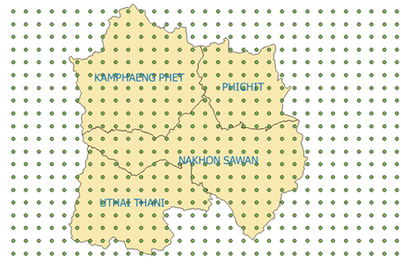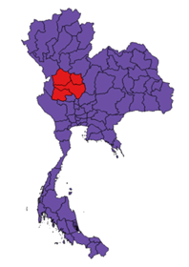

**Fig.2.** Rain fall data observation points and geographical boundaries of all four provinces

**Table 2.**Fragment of rainfall data text file from GSMap_NRT

|  |  |  |
| --- | --- | --- |
| **Lat** | **Lon** | **RainRate** |
| 20.95 | 97.05 | 0.1 |
| 20.85 | 97.05 | 0.06 |
| 20.75 | 97.05 | 0.04 |
| 20.65 | 97.05 | 0.06 |

No pre-processing was conducted on temperature and population data. Each factor has outliers. A careful decision has to be made on outliers as these may be a result of an outbreak rather than just an outlier. An outbreak can be a result of many other factors and rainfall may or may not contribute to the outbreak. As a model generalization step, we do not consider extreme values as outliers in this study. We keep further investigations on this scenario to be covered in future works of this study.

**3.3 Pre-analysis of Data**

The proposed model used in this study is the SVR [15]. SVR is built on regression analysis. To get a better result from a regression analysis, there must be a positive correlation between explanatory variables (factors) and dependent variable (dengue cases). As the primary model of prediction is SVR, this study needs a data analysis before moving forward with SVR. A separate correlation analysis was conducted for each factor (rain, temperature and population) to determine the suitability of the regression analysis of the proposed factors. Correlation is a statistical relationship between those two sets of data which describes the strength of the relationship between those two data sets in consideration. If the correlation is low there is a weak interdependency between those two sets. If the correlation is high(normally greater than 0.5 negative or positive), there is a considerable relationship between those two sets. Correlation of two data sets is computed as given in the equation below.

(1)

Where is the correlation between datasets X and Y. E is the expected value operator. is the mean of data set X, is the mean of data set Y. and are standard deviation of data sets X and Y respectively.The correlation value is generally interpreted as shown in table 3.

**Table 3.** Correlation values and their meanings

|  |  |
| --- | --- |
| Correlation Value | Interpretation |
| -1 | A perfect downhill (negative) linear relationship |
| -0.7 | A strong downhill (negative) linear relationship |
| -0.5 | A moderate downhill (negative) relationship |
| -0.3 | A weak downhill (negative) linear relationship |
| 0 | No linear relationship |
| +0.3 | A weak uphill (positive) linear relationship |
| +0.5 | A moderate uphill (positive) relationship |
| +0.7 | A strong uphill (positive) linear relationship |
| +1 | A perfect uphill (positive) linear relationship |

**3.4 Model Generation**

Behavior of each factor (rainfall, temperature and population density) on dengue cases is spatially dependent. That is the effect of rainfall on dengue for each district is different from district to district as presented in [5]. Hence, a separate analysis for each district was conducted and a separate model for each province was generated. Data for five years were combined together for each district and fed into the model for training. The proposed arrangement can capture the spatial heterogeneity of each province and hence improve the performance of prediction model.

The SVR model is based on the regression analysis. A regression analysis can estimate the relationship between two data sets (random variable) and fit a cure to the data sets (explanatory variable and dependent variable). This curve can then be used in prediction of unknown cases. The regression curve for this study has three explanatory variable, Rain R, Population P, and Temperature T. The regression model for this study is given in the equation below.

(2)

Where Pi is the population in *i*th region, Ri is the rainfall for *i*th region and is the temperature for *i*th region. The error term is . is the dengue cases for region *i*. Intercept is , a constant.

SVR improves the detection speed as it keeps only a subset of training data as support vectors in the model. The SVR uses the same principles as the Support Vector Machine (SVM) for classification, with only a few minor differences. SVR’s output is a real number which makes it difficult to match target output on test dataset. A margin of tolerance (epsilon) is set in approximation to the SVM to address the problem associated with real numbers output.  General construction of SVR is given in the following equations.

SVM regression is constructed by first mapping the input vector X into an m-dimensional feature space using a non-linear mapping function. The linear regression model is then constructed in this feature space. The linear model  is given by equation 3.

   (3)

Where   denotes a set of nonlinear transformations and b is the “bias” term. The bias term can be dropped with the assumption of zero mean data set. is the normal vector.

The quality of estimation is measured by the loss function given in equation 4. The loss function is computed as proposed in [16].

(4)

Then the empirical risk function is given in equation 5.

           (5)

            The model generated by minimizing the . This can be achieved by introducing (non-negative) slack variables to measure the deviation of training samples outside http://kernelsvm.tripod.com/index_files/image032.gif-insensitive zone. Thus the SVM regression is formulated by minimization of the function given in equation 6.

(6)

Such that

This optimization problem can transformed into the dual problem and its solution is given by the equation in 7.

(7)

Such that:

Where is the number of Support Vectors (SVs) and the kernel function is given by the equation in 8.

  (8)

The RBF was used as the kernel function and epsilon was set to 0.001. The cost parameter was kept at 100.

**3.5 Prediction**

A vector of unseen data for rainfall, temperature and population data is fed into the trained model and estimated output is obtained from the SVR. This output is not a label as in SVM. Rather it is a real number approximating the number of dengue cases pertaining to the given scenario. The number of cases predicted show cases the severity of the condition that may occur if the given scenario appears in the future.

**3.6 Model Validation**

Conventional regression models are evaluated based on the MSE of the cross validation (mostly 10-fold cross validation). MSE cannot capture the total picture of the behavior of the data set. Several outliers can affect the final outcome of the validation. Another problem of regression analysis is there is no way of computing the accuracy of the prediction with cross validation. Regression gives real values as estimates and there is theoretically infinite number of possibilities with a real number. This fact makes it impossible to compare against target value. Accuracy is computer as per the following equation in SVM like classifiers. SVM like classifiers are based on class labels and hence makes it possible to compute accuracies conveniently.

(9)

Where ACC is accuracy, TF is true positives, TN is true negative, FP is false positive and FN is false negative. In this study a novel yet simple accuracy calculation method was introduced. A positive confidence boundary parameter α was included in cross validation. If *|actual value – estimated value| > α*, we label the estimated value as a correct prediction and incorrect prediction otherwise.

**Determination of the degree of fit of the regression model to the dataset with parameter alpha (α).** The value of *α* is inversely proportional to the model accuracy. If the model generates a higher accuracy value for a lower value of *α,* the regression model fits relatively well to the dataset. If the model accuracy is high only for a large value of *α, the* dataset is loosely correlated to the influencing factors. Higher accuracy for a smaller alpha value indicates that the dataset and the fitted regression is a best fit for the problem domain.

Outlier removal

Dengue case data is reported partly or fully. If the data reported is partial, then the relationship between influencing factors and dengue cases is not clearly seen. Some elevated numbers have the same effect on the modeling. It is critical to identify these instances in advance and treat them properly to ensure the quality of the generated predictive model. These unusual instances are known as outliers. I proposed a method of outlier removal in which a convex hull is used to determine the outliers. This method uses the fact that the outliers (extreme points) lie further to actual points. As the correlation between influencing factors and the dengue cases reported is strong, the chance of having an observation that position further away from the cluster of points is less. This techniques is shown in the

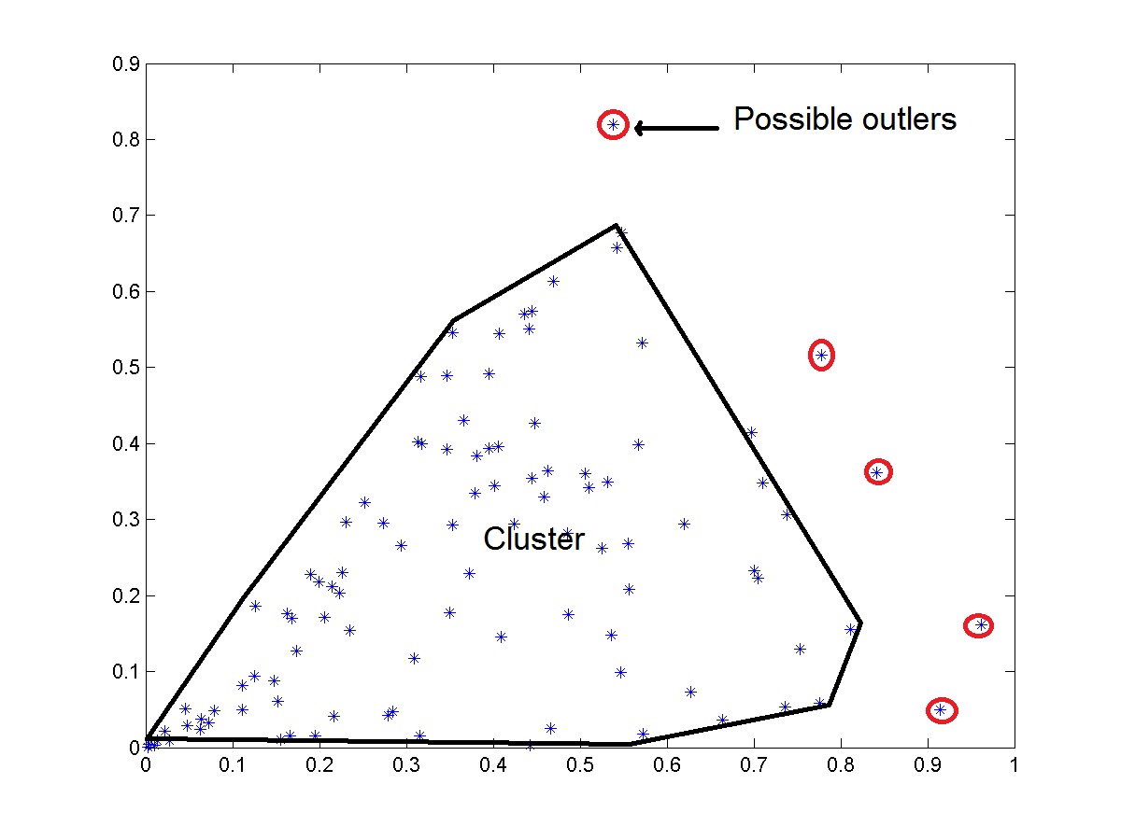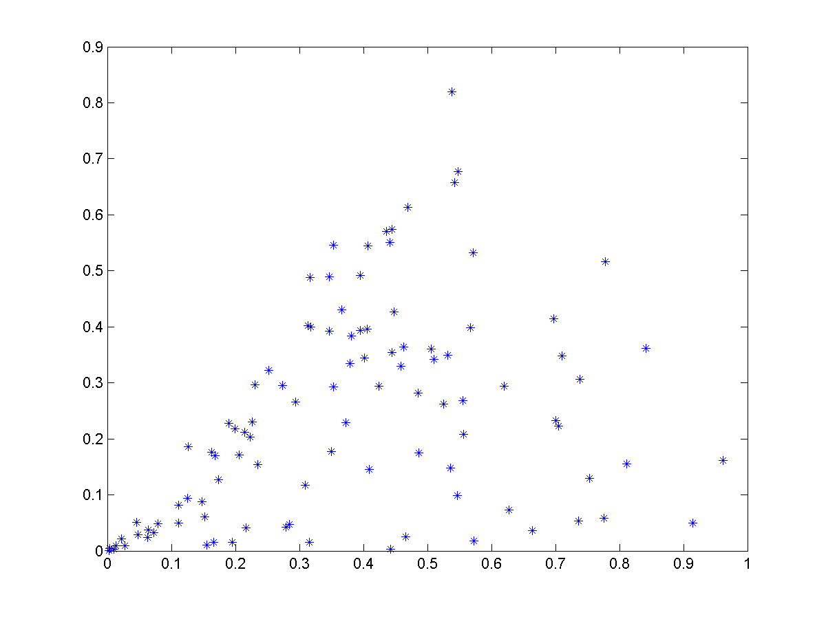

figure .

Proposed method operates in two stages. Identification of the presence of an outlier and removal of identified outlier. In the first stage, a convex hull generated for the two-dimensional representation of each influencing factor to the dengue cases reported. This stage is shown in the figure with and without outliers . Then the surface area covered by the convex hull is computed. Next, the points that formed the convex hull are removed from the original data set and regenerate the convex hull for the remaining points. The presence of an outlier is determined by a significant difference in surface areas computed. The algorithm advances to the second stage to identify the exact outlier from the set of points that formed the convex hull. Finally, I remove the identified outlier from the original dataset.

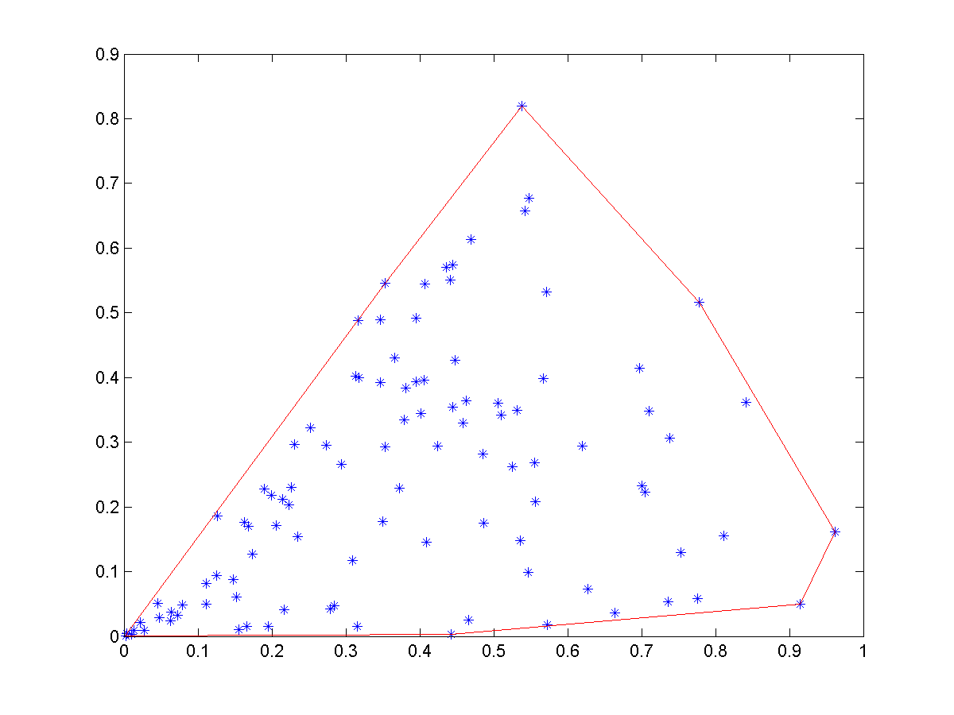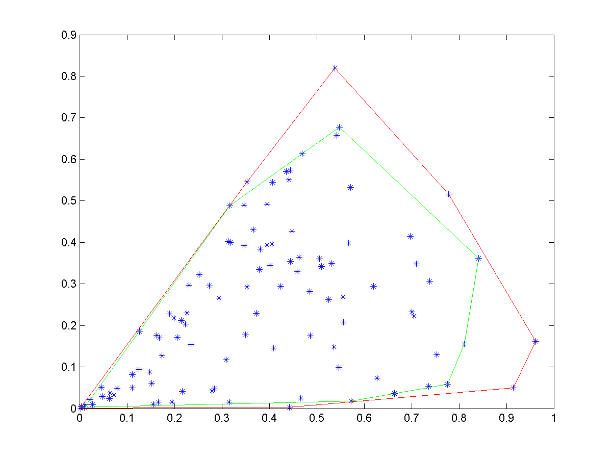

Figure

Iterative convex hull reduction to remove outliers

Outlier removal takes place as an iterative process. First, the convex hull of the two dimensional dataset is generated. The area of the outer most convex hull is computed. In the next iteration, the points that formed the convex hull are removed from the original data set and regenerate the convex hull for the remaining points. Compute the difference in areas of the convex hull generated from the previous iteration to the current iteration. Iteration stops if the difference in areas is below a predetermined threshold value or preset number of maximum iterations reached. If the difference in area is significant, that indicates the presence of outlier and hence need to determine the outlier. The theory behind the outlier removal process is that the area difference is directly proportional to the number of outliers and the severity of the outlier (how far from the cluster of points).

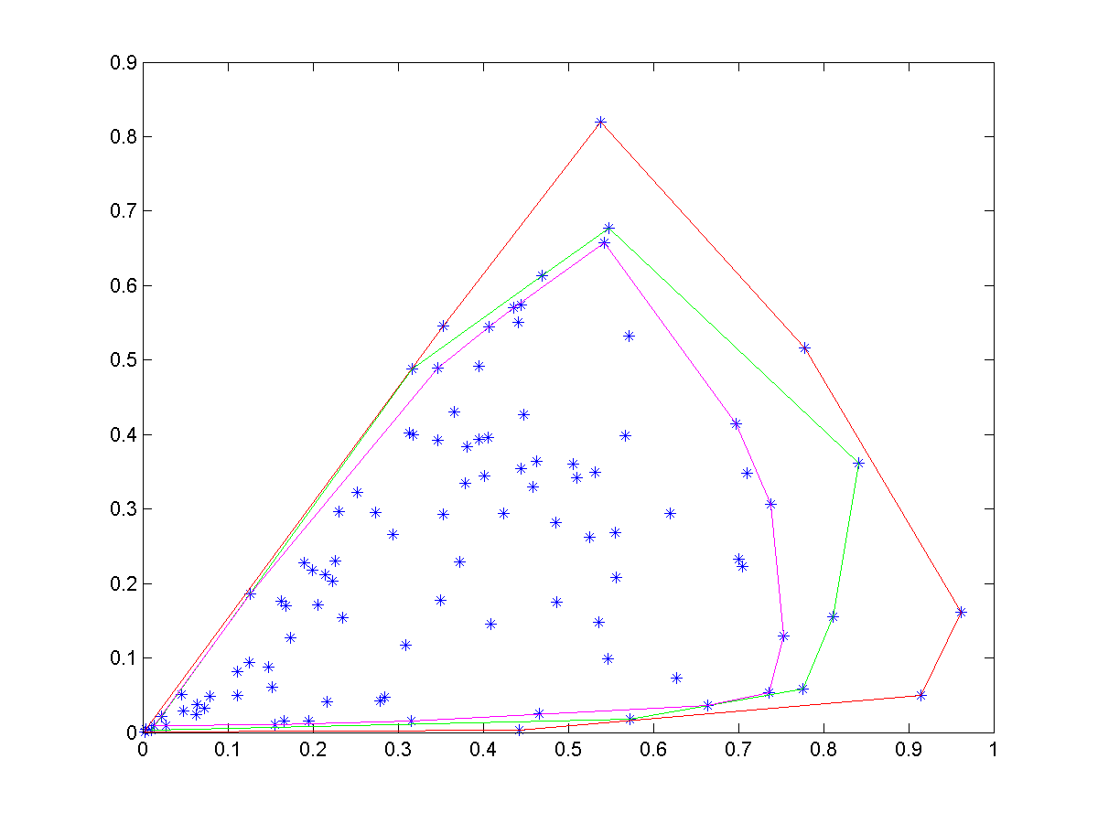

Let ΔA is the difference in area between two iterations.

**Determination of point to be removed from outer convex hull in the presence of outliers**

Once the presence of outliers detected, it is necessary to identify the exact outliers from the points on outer convex hull. This step is important as all the points that make outer convex hull are not outliers. I follow the exhaustive search approach to identify the outliers among points on outer convex hull. I compute the difference in surface area keeping one point of the convex hull out. All the points that generate a difference in area greater than or equal to predetermine threshold value are classified as outliers. All the remaining points will remain in the dataset.

Resource Allocation

A successful mitigation plan includes an effective resource allocation scheme. An effective resource allocation should eliminate wastage, over allocation and under allocation of resources while satisfying the demand of each facility for a given resource. Over allocating may result in run out of available resources before every demand is satisfied. Under allocating may result in failure of mitigation plan. Hence, an effective resource allocation is needed to ensure a proper distribution of available resources among facilities to satisfy their demands.

Problem definition

Let F1,F2….Fn is the set of facilities demanding for resources R1, R2,……Rm with a demand for each resource W00, W01,…….Wnm. with the constraint . As the available resources may not be sufficient enough to fulfill the demand of each facility, the allocation algorithm must generate an optimum allocation that minimizes the penalty of allocating less than the demand. The final allocated scheme is represented as A00, A01,…..Anm. This problem can be modeled as a bi-partite matching between facilities and resources with a weight o each mapping as the demand. I represent this problem using a bi-partite grape as show in figure.

Problem representation

The problem of resource allocation with demand can be successfully represented with a bi-partite graph. The graph is constructed as resources and facilities as two sides and demand as weight of associations. The graphical representation can be seen in figure . In the figure resources are represented with R0…Rm, facilities are represented with F0,…Fn and corresponding demands are represented with W00,…..Wnm.

F1

Fn

Rm

Rm

W02

Wij

Digital Representation

The resource allocation problem is represented as an adjacency matrix that is algorithm friendly. Resources are arranged along x axis and facilities are arranged along y axis. Weight (demand) of the matching is the corresponding element of the matrix.

Demand of resources

F1

.

.

Fn

R1 . … … … Rm

Allocation of resources

R1 . … … … Rm

F1

.

.

Fn

Finding the optimum solution for resource allocation problem

The best allocation is to deliver each facility resources they demanded. The scarcity of resources prevents us from delivering the demanded amount of resources for all the facilities. It is required to find the optimum resource allocation that will minimize the impact of being delivered below the demanding amount. It is required to determine an effective method of calculating the impact of resource allocation on each facility. I suggest calculating a penalty score for each facility based on its important properties. The severity of allocating fewer resources than demanded is depended on the population that needed to be served and surface area of the serving region. The penalty score is calculated according to the equation given below.

The goal of the minimization algorithm is to minimize the total penalty score which is given in the equation below.

Weight adjustments

The best approach is to use exhaustive search to look for the best match for weight for allocated matrix. The number of candidates in the exhaustive search space is increased exponentially with the number of facilities and number of available resource categories. The exhaustive search is then become resource intensive and is not an ideal candidate to find weights of the allocated matrix. I propose to use Genetic Algorithm approach with several modifications to match the problem domain.

Genetic Algorithm can be successfully applied in searching for a best fit from large number of candidate solutions. GA performs best when the available number of candidates is high. State of the art GA is defined as follows.

Genetic Algorithm is an optimization technique built on the principle of Genetics and Natural Selection. GA comes under the category machine learning. Given a set of possible solutions to the given problem, GA tries to select the best match based on the criteria set in advance. The GA selects a subset of population that meets the given criteria. This subset undergoes two steps, namely crossover and mutation, producing new children similar to natural process of selecting best fit candidates. This process is repeated over several iterations. Each candidate solution is assigned a fitness value and the fitter individuals are given a higher chance to mate and yield more “fitter” individuals.

GAs is randomized in nature when selecting crossover points and mutation points. The randomness in crossover and mutation is not applicable in my problem domain. I introduce a variant of crossover and mutation such that the resulting off springs are compliance with the requirements of the resource allocation.

I propose several major modifications to the standard GA for achieving optimum results for the resource allocation problem. These modifications are generalized and can be applied to any resource allocation problem. The modifications are listed below.

1. Introducing chromosome representation for resource allocation
2. Change the way the standard GA generates the initial population.
3. Chane the way the standard GA does crossover operation
4. Change the way the standard GA does mutation
   1. Introduction of resource lock chromosome
   2. Introducing sliding mutation scheme to accelerate the convergence
5. Change the iteration of the GA to accommodate sliding mutation scheme

All the above stages are detailed in the following sections.

GA representation of the problem

The problem of allocating set of resources among set of facilities must be represented in a single string of genes called a chromosome. I select decimal numbers in each location of gene as oppose to binary digits in standard GA. The binary chromosome and the proposed chromosome are given in the figure below.

Standard binary chromosome

|  |  |  |  |  |  |  |  |  |  |
| --- | --- | --- | --- | --- | --- | --- | --- | --- | --- |
| 1 | 1 | 0 | 0 | 0 | 1 | 0 | 1 | 1 | 0 |

Proposed chromosome

|  |  |  |  |  |  |  |  |  |  |
| --- | --- | --- | --- | --- | --- | --- | --- | --- | --- |
| W11 | W12 | .. | W1m | .. | .. | Wn1 | Wn2 | .. | Wnm |

Gene Boundary for Facility 1

As shown in the figure, resources for a given facility must be placed in adjacent genes of the chromosome. Gene boundary is used here after throughout the document as to represent the set of resources for a given facility.

Resource allocation requirements that must be embedded in GA are given below.

* Total number of allocated resources must match the total number of available resources when performing mutations.
* The Gene Boundary must not be broken apart when performing crossovers.

Proposed Population Generation Procedure

As opposed to the standard GA I use a customized population generation technique. In the proposed scheme, a constraint is set forth and eliminates chromosomes that violate the constraint. All the resulting chromosomes allocate resources that are under the limits of availability of resources. The constraint is modeled as shown in equation . The number of facilities is n and number of resources is m.

Constraint -> Available amount of resources (i)

Proposed Crossover Operation

Crossovers are performed such that the gene boundaries are preserved. A gene boundary is treated as a single entity in crossover and hence the problem reduced to binary crossover in standard GA. A sample crossover is shown in figure .

Chromosome 1

|  |  |  |  |  |  |  |  |  |  |
| --- | --- | --- | --- | --- | --- | --- | --- | --- | --- |
| W11 | W12 | .. | W1m | .. | .. | Wn1 | Wn2 | .. | Wnm |

Crossover point

Chromosome 2

|  |  |  |  |  |  |  |  |  |  |
| --- | --- | --- | --- | --- | --- | --- | --- | --- | --- |
| W11 | W12 | .. | W1m | .. | .. | Wn1 | Wn2 | .. | Wnm |

Resulting Chromosomes

|  |  |  |  |  |  |  |  |  |  |
| --- | --- | --- | --- | --- | --- | --- | --- | --- | --- |
| W11 | W12 | .. | W1m | .. | .. | Wn1 | Wn2 | .. | Wnm |

|  |  |  |  |  |  |  |  |  |  |
| --- | --- | --- | --- | --- | --- | --- | --- | --- | --- |
| W11 | W12 | .. | W1m | .. | .. | Wn1 | Wn2 | .. | Wnm |

Proposed Mutation Operation

The proposed mutation operation selects number of mutation points based on the mutation rate as like standard GA. It is required to make sure that the resulting chromosome is adhering to the requirements set forth by the problem domain as opposed to standard GA. In standard GA it is simply select random points based on the mutation rate and flip the selected bit. In the proposed mutation operation, if the resulting chromosome demands more resources than available amount of resources after mutation it is not a good fit. A random mutation is not suitable in the proposed problem domain. A constraint must be set in mutation operation to consider the total amount of allocation for a given resource must not exceed the total amount of availability of the resource.

I randomly pick a resource type from the list of available resources. Next, set of facilities is randomly picked to apply the mutation. A resource exchange operation takes place between selected facilities for randomly selected resource type. This will make sure that the allocated amount of resources is not exceeding the available amount of resources. The proposed mutation operation is shown in figure . Let the mutation operation randomly picked facility 1 and facility n for resource exchanging. All the other facilities remain unchanged and resource type 1(Wi1) was randomly selected for mutation.

Chromosome 1

|  |  |  |  |  |  |  |  |  |  |
| --- | --- | --- | --- | --- | --- | --- | --- | --- | --- |
| W11 | W12 | .. | W1m | .. | .. | Wn1 | Wn2 | .. | Wnm |

Facility 1 Facility n

Mutation -> W11 = W11 – a Mutation -> Wn1 = Wn1 + a

Fitness function

The fitness function is modeled as a function of risk associated with the given facility based on the location of the facility, population count of the facility, amount of area to be served by the facility. The proposed method of fitness calculation will make sure that resources are allocated appropriately. Final fitness value is computed for all the facilities (from facility Fi=0 to n) for all the resources (from resource Rj=0 to m) together as shown in the equation .

Proposed Iteration Procedure

The Proposed Concept of Locked Genes

In the real-world settings, the possibility of having more of a certain resource than the total demand from all the facilities is not rare. This will bring up a concern that the amount of time we spend on mutating and cross over on that resource is a waste of computational time. We can improve the performance of the GA by eliminating these resource in the iterations. I proposed a concept of locked genes in to the standard GA in which genes that has more resources than requested are locked. The GA does not mutate the locked genes. There will be a in memory locked chromosome as a reference for GA to use in each iteration. Sample lock chromosome is given in figure . The sample chromosome is generated for two facilities requesting five resources. The first resource is abundant and hence needed to be locked. Other four resources are not abundant and hence needed to be allocated efficiently via GA.

|  |  |  |  |  |  |  |  |  |  |
| --- | --- | --- | --- | --- | --- | --- | --- | --- | --- |
| 1 | 0 | 0 | 0 | 0 | 1 | 0 | 0 | 0 | 0 |

Figure : Lock Chromosome for two facilities with five resources. First resource is abundant and hence locked.

Proposed Sliding Mutation Scheme

Standard GA uses random mutation and crossover operations. This will inherently produce random children and hence the fitness of the generated child will greatly be varying. The algorithm selects chromosomes randomly to apply the two operations. This will lead to lower the fitness of the selected best fit chromosome as well. To reduce the fluctuation of fitness, I introduce a new method of mutation in each iteration. The proposed method will make sure that the next generation will be generated based on a sliding mutation scheme where the amount of mutation applied to a given chromosome is proportional to the risk associated with the chromosome. This method will mutate chromosomes with an amount that proportional to the risk associated with the chromosome. This will drive each chromosome gradually towards the best fit. The cross over operation will ensure that the GA will not end up in a local minimum. The experimental results proved that the proposed scheme perform very well and resulted in a higher bet fit value than standard GA in all the trials that performed. The proposed sliding mutation is given in equation below.

randomMutation = rand (0, (CurrentAllocation * Risk) );

The figure shows the pseudocodes of the proposed GA with modifications and standard GA. Added steps are bolded in the proposed GA.

|  |
| --- |
| **Algorithm 1**: Standard GA |
| 1: k ← 0;  2: PK ← InitPopulation(n) {Generating Initial Population with n individuals}  3: Compute fitness(i) for each i ∈ Pk; {Evaluate everyone in the population Pk: }  **4: While** not termination **do**  5: Select (1 − ChurnEntropy) × n members of Pk and insert into Pk+1; { Select Subset of PK:}  6: Select ChurnEntropy × n members of Pk; pair them up; produce offspring; insert the offspring  into Pk+1; { Crossover:}  7: Select MutationEntropy × n members of Pk+1; invert a randomly-selected bit in each;  {Mutate}  8: Compute fitness(i) for each i ∈ Pk; { Evaluate Pk+1:}  9: k ← k + 1;  **10: end while**  11: return the fittest individual from Pk; |

|  |
| --- |
| **Algorithm 2**: Proposed GA |
| 1: k ← 0;  2: PK ← InitPopulation(n, **resourcesMap**) {Generating Initial Population with n individuals and  constraints}  3: Compute fitness(I, facilityInfo) for each i ∈ Pk; {Evaluate everyone in the population Pk: }  **4: While** not termination **do**  5: Select (1 − ChurnEntropy) × n members of Pk and insert into Pk+1; { Select Subset of PK:}  6: Select ChurnEntropy × n members of Pk; **generate crossover with constraints**; insert the  offspring into Pk+1; { Crossover:}  7: Select MutationEntropy × n members of Pk+1; **perform constrained and sliding mutation**  **based on risk**; {Mutate}  applyRiskBasedPenalty for each individual; {applying over and under allocation penalty}  8: Compute fitness(i) for each i ∈ Pk; { Evaluate Pk+1:}  9: k ← k + 1;  **10: end while**  11: return the fittest individual from Pk; |

Figure : Standard and Proposed GA for resource allocation

Results:

**Thailand**

Correlations

The prerequisite for a regression analysis is to have a strong correlation between independent variables and dependent variable. I conducted a complete correlation analysis on independent variables (rainfall, temperature, population densities and NDVI) and dependent variable dengue cases. The results are given in the following.

**Table 4.**Correlation analysis results for four provinces for dengue cases and rainfall data

|  |  |  |  |  |
| --- | --- | --- | --- | --- |
| **Year\District** | **Kamphaeng Phet** | **Nakhon Sawan** | **Pitchit** | **Uthai Thani** |
| 2007 | 0.62 | 0.54 | 0.61 | 0.61 |
| 2008 | 0.71 | 0.75 | 0.84 | 0.50 |
| 2009 | 0.81 | 0.59 | 0.46 | 0.26 |
| 2010 | 0.91 | 0.82 | 0.64 | 0.87 |
| 2011 | 0.62 | 0.61 | 0.70 | 0.58 |

I also conducted a correlation analysis for all five years together. The result was less correlated than individual year. Nevertheless there is a good correlation between factors for all five years as well. The correlation results for full data set for each province are given in the table 5.

**Table 5.** Correlation analysis results for four provinces for dengue cases and rainfall data for all five years together

|  |  |  |  |  |
| --- | --- | --- | --- | --- |
|  | **Kamphaeng Phet** | **Nakhon Sawan** | **Pitchit** | **Uthai Thani** |
| All five years | 0.60 | 0.53 | 0.57 | 0.40 |

Dengue least square analysis

GWR analysis

Correlation graphs

Outlier removal graphs

Model validation results

We conducted 10-fold cross validation to assess the performance of the model. A novel method of summing the results of all ten folds was introduced in the methodology section 3.6. We present the results of our novel method computing accuracies of each fold below. Two trials were run for provinces Kamphaeng Phetand Uthai Thani those have the highest and the lowest correlation values.Other two provinces generated a medium accuracy that is between Kamphaeng Phetand Uthai Thani acuracies. Therefore we present only the highest (Kamphaeng Phet)and the lowest (Uthai Thani). The corresponding accuracies for each trial and for each province are listed in table 6.

**Table 6**.Accuracies for 10-fold cross validation and average accuracy

|  |  |  |  |  |
| --- | --- | --- | --- | --- |
| **Fold** | **Kamphaeng Phet** | | **Uthai Thani** | |
| **Alpha = 50** | | **Alpha = 50** | |
| **Trial 1** | **Trial 2** | **Trial 1** | **Trial 2** |
| 1 | 100 | 66.6 | 50.0 | 83.0 |
| 2 | 100 | 83.3 | 50.0 | 83.0 |
| 3 | 66.6 | 66.6 | 16.0 | 66.0 |
| 4 | 66.6 | 83.3 | 66.0 | 50.0 |
| 5 | 66.6 | 50.0 | 66.0 | 50.0 |
| 6 | 66.6 | 66.6 | 50.0 | 50.0 |
| 7 | 33.3 | 50.0 | 83.0 | 83.0 |
| 8 | 83.3 | 66.6 | 83.0 | 50.0 |
| 9 | 50.0 | 100 | 66.0 | 50.0 |
| 10 | 83.3 | 83.3 | 66.0 | 83.0 |
| **Average** | **71.63** | **71.63** | **59.6** | **64.8** |

Prediction results

In addition, we visualize the actual case data against the estimated value of the model during the cross validation. The results of the visualization are given in figure 3.

**Data point**

(a)

**Data point**

(b)

**Fig.3.**Actual values and predicted values during 10-fold cross validation process for (a) Kamphaeng Phetand (b) Uthai Thani provinces.

Resource allocation results

Compare with exhaustive search

**Sri Lanka**

Correlations

Dengue least square analysis

In OLS results VIF values shows whether the predictor variables are multicollinear. VIF < 10 means the variables are not multicollinear. In this study, rainfall and population density were used as explanatory variables. VIF value determined these two factors are not correlated and hence can be used in regression analysis together. Every explanatory variable used is unique and contributing to the variation in dengue incidence. OLS regression result also shows that the Adjusted R-Squared value is 0.332054 for the year 2014. This indicates the model built with a combination of population density and rainfall data explains 33.2% of the variation in dengue incidences. According to the OLS regression results, all explanatory variables (rainfall and population density) are statistically significant but the value for Jarque-Bera statistics is also significant. Significance in Jarque-Bera statistics indicates the model is biased and hence undesirable. Also the Koenker test is statistically significant (P value < 0.01 for both rainfall and population). This implies non-stationary relationship between the dependent and some or all of the explanatory variables. That reveals the explanatory variables (rainfall and population density) behave differently in different spatial regions.



**Figure 2:** Spatial distribution of dengue incidence from 2011 to 2015 in Sri Lanka.

GWR analysis

For GWR, adaptive kernel was used as kernel type and AIC was selected as bandwidth. In GWR AIC value determines the performance of the model. AIC can be used to compare two different models generated with regression analyses. AIC value for OLS is greater than in GWR. Hence GWR is a better analysis tool for dengue incidence with rainfall and population density as explanatory variables.

The GWR model results show that the Adjusted R-Squared values is 0.5632 (R2= 0.621). This indicates the model generated with population density and rainfall as explanatory variables can explain 56.3% of the variance in dengue incidences in 2014. These results also reveal that there are other variables besides population density and rainfall data that has stronger relationships with dengue incidence. These variables are not included in the model. But the model cannot provide a clue of those variables so that they cannot be included in the model. They have to be identified by experimenting with various candidate explanatory variables.



**Figure3:** GWR standard residual map for dengue incidence with rainfall and population density for the year 2014.

The standard residual map for the model developed for dengue incidence is shown in the Figure 3. The red areas indicate under predictions where the actual number of dengue cases is higher than the model predicted values. The blue areas indicate over predictions where actual dengue cases are lower than predicted values. Random locations of red or blue areas indicate the model performs fairly well. Red or blue clustered areas indicate under/over prediction of the model and hence the performance of the model is poor. Spatial clustering of over/under prediction indicates missing one or more key explanatory variables in the model. The standard residual map in Figure 3 shows clustered over and under predicted areas.

It is required to find how well each explanatory variable predicts the dengue incidence for each administrative region. It is revealed from previous sections that there are no global explanatory variables that hold consistent relationship across administrative regions. An analysis was conducted to reveal the variation in strength of explanatory variables in each administrative region in explaining the relationship between the variable and dengue incidence. Results of the analysis are shown in Figure 4 (a) and Figure 4 (b). Figure 4 (a) provides the spatial distribution of regression coefficients for rainfall and Figure 4 (b) provides the same for population density. Lighter colors represent lower coefficients and darker colors represent higher coefficients.

Mapping these coefficients shows the relationship between each explanatory variable and the dependent variable that how they change across the study area. The darker areas in figures indicate the explanatory variables, rainfall and population density, are strong predictors of the dengue incidence, whereas, the lighter areas are locations where they are comparatively weak.

GWR regression results show that relationship of incidence with rainfall and population density is spatially varying across districts of Sri Lanka. Figure 4(a) shows that spatial distribution of regression coefficient of population density is a strong predictor in eastern coastal areas mainly in Trincomalee district, and a weak predictor in Mannar. Figure 4(b) also shows that spatial distribution of regression coefficient of rainfall is a strong predictor in northern areas including Mannar and in eastern coast it is a weak predictor. There is an inverse effect of rainfall and population density on dengue incidence. When rain becomes a strong predictor in some areas population density is a weak predictor and vise versa. It is very important to understand this variation for making local policies to mitigate dengue. GWR model can also be used to predict values of dependent variables for locations within the study area with unseen explanatory variables values. This will give an estimate of the dependent variable (dengue incidence) using the regression model generated.



**Figure 4:** spatial distribution of regression coefficients for (a) population density (b) rainfall.

Correlation graphs

Outlier removal graphs

Model validation results

Prediction results

Resource allocation results

I performed resource allocation on five different synthetic datasets confirming to the setting listed in the table . I listed the complete setup for the first trial and only list best fit value graph and the allocation results for the remaining trials. All the other results are found under appendix A.

|  |  |  |  |
| --- | --- | --- | --- |
| Trial No | Number of facilities | Number of Resources | Facility Properties |
| 1 | 10 | 10 | 5 |
| 2 | 50 | 5 | 5 |
| 3 | 100 | 10 | 5 |
| 4 | 500 | 10 | 5 |
| 5 | 1000 | 10 | 5 |

Performance Comparison of GA with random and sliding mutation with lock chromosome

Trial 1

Facility Information (High risk facility that is not resource locked is highlighted in red)

|  |  |  |  |
| --- | --- | --- | --- |
| **Population** | **Risk** | **No. of Doctors** | **No. of attendants** |
| 293931 | 4435 | 259 | 655 |
|  |  |  |  |
| 424873 | 2722 | 619 | 233 |
| 300904 | 1930 | 743 | 264 |
| 222133 | 4372 | 195 | 954 |
| 185651 | 2426 | 328 | 185 |
| 257318 | 2368 | 354 | 742 |
| 453762 | 2720 | 522 | 419 |
| 141650 | 1956 | 493 | 174 |
| 402820 | 1555 | 128 | 720 |
| 259771 | 1944 | 840 | 466 |

Resource Availability

|  |  |  |  |  |  |  |  |  |  |
| --- | --- | --- | --- | --- | --- | --- | --- | --- | --- |
| **R1** | **R2** | **R3** | **R4** | **R5** | **R6** | **R7** | **R8** | **R9** | **R10** |
| 1304 | 7441 | 7297 | 980 | 6276 | 9691 | 5735 | 6476 | 2754 | 146 |

Requested Resources from each facility

|  |  |  |  |  |  |  |  |  |  |  |
| --- | --- | --- | --- | --- | --- | --- | --- | --- | --- | --- |
| **Resource**  **Facility** | **R1** | **R2** | **R3** | **R4** | **R5** | **R6** | **R7** | **R8** | **R9** | **R10** |
| F1 | 43 | 369 | 362 | 49 | 208 | 481 | 190 | 214 | 91 | 5 |
| F2 | 66 | 564 | 553 | 74 | 317 | 734 | 290 | 327 | 139 | 7 |
| F3 | 55 | 467 | 458 | 61 | 262 | 608 | 240 | 271 | 115 | 6 |
| F4 | 207 | 1770 | 1735 | 233 | 995 | 2305 | 909 | 1027 | 437 | 23 |
| F5 | 102 | 875 | 858 | 115 | 492 | 1140 | 450 | 508 | 216 | 11 |
| F6 | 207 | 1770 | 1735 | 233 | 995 | 2305 | 909 | 1027 | 437 | 23 |
| F7 | 129 | 1108 | 1087 | 146 | 623 | 1444 | 570 | 643 | 273 | 14 |
| F8 | 164 | 1400 | 1373 | 184 | 787 | 1823 | 719 | 812 | 345 | 18 |
| F9 | 189 | 1614 | 1583 | 213 | 908 | 2102 | 829 | 936 | 398 | 21 |
| F10 | 143 | 1225 | 1201 | 161 | 689 | 1595 | 629 | 711 | 302 | 16 |

Lock Chromosome

|  |  |  |  |  |  |  |  |  |  |
| --- | --- | --- | --- | --- | --- | --- | --- | --- | --- |
| 0 | 0 | 0 | 0 | 1 | 0 | 1 | 1 | 1 | 1 |

Performance of the GA for random, no-sliding with constraints and sliding with constraints GAs. There are 10 facilities with four properties. Each facility is requesting 10 different resources.

Resource Allocation Results

High risk facility

Lowest risk facility

Trial 2

Performance of the GA for random, no-sliding with constraints and sliding with constraints GAs. There are 50 facilities with four properties. Each facility is requesting 5 resources.

The high-risk facility is the facility 27. The following graphs shows the resource allocation for the facility 27 with random GA and sliding with constrained GA.

Trial 3

Performance of the GA for random, no-sliding with constraints and sliding with constraints GAs. There are 100 facilities with 4 properties that request for 10 resources.

The high-risk facility is the facility 49. The following graphs shows the resource allocation for the facility 49 with random GA and sliding with constrained GA.

# BIBLIOGRAPHY

[1]. P.D.N.N. Sirisena, F. Noordeen, “Evolution of dengue in Sri Lanka—changes in the virus, vector, and climate”. International Journal of Infectious Diseases, 19 (2014) 6–12

[2] M. O Neill II, A. R. Mikler, and T. Schneider. An Extensible Software Architecture to Facilitate Disaster Response Planning. 2011.

[3]. Vitarana T, Jayakuru WS. Historical account of dengue haemorrhagic fever in Sri Lanka. WHO/SEARO Dengue Bulletin 1997;21:117–8.

[4]. Kanakaratne N, Wahala MP, Messer WB, Tissera HA, Shahani A, Abeysinghe N, et al. Severe dengue epidemics in Sri Lanka 2003–2006. Emerg Infect Dis 2009;15:192–9

[5]. Kusumawathie PH, Fernando WP. Breeding habitats of Aedes aegypti Linnaeus and Ae. albopictus Skuse in a dengue transmission area in Kandy, Sri Lanka. The Ceylon Journal of Medical Science 2003;46:51–60

[6]. Kusumawathiea PH, Yapabandarab AM, Jayasooriyaa GA, Walisingheca C. Effectiveness of net covers on water storage tanks for the control of dengue vectors in Sri Lanka. J Vector Borne Dis 2009;46:160–3

[7]. McMichael AJ, Woodruff RE, Hales S. Climate change and human health: present and future risks. Lancet 2006;367:859–69

[8]. Dorji T, Yoon IK, Holmes EC, Wangchuk S, Tobgay T, Nisalak A, et al. Diversity and origin of dengue virus serotypes 1, 2, and 3, Bhutan. Emerg Infect Dis 2009;15:1630–2.

[9]. Department of Health Service, Sri Lanka. Annual health bulletin of Sri Lanka. Colombo, Sri Lanka: Department of Health Services; 2002.

[10]. Briet OJ, Galappaththy GN, Konradsen F, Amerasinghe PH, Amerasinghe FP. Maps of the Sri Lanka malaria situation preceding the tsunami and key aspects to be considered in the emergency phase and beyond. Malaria J 2005;4:8.

[11]. Ministry of Health, Sri Lanka. Surveillance report on dengue fever/dengue haemorrhagic fever 2007. Epidemiological Bulletin 2008;49:1–20.

[12]. Ministry of Healthcare and Nutrition of Sri Lanka. Monthly distribution of suspected dengue cases from 2004 to 2010 by District in Sri Lanka. Ministry of Healthcare and Nutrition of Sri Lanka, 2011. Available at: http://www.epid.- gov.lk/Den- gue_updates.htm (Accessed on 20th of August 2013).

[13]. Martha A, Yuzo A. Male–female differences in the number of reported incident dengue fever cases in six Asian countries. Western Pac Surveill Response J 2011;2

[14]. Weaver SC, Reisen WK. Present and future arboviral threats. Antiviral Res 2010;85:328.

[ 15]. Cavrini F, Gaiban P, Pierro AM, Rossini G, Landini MP, et al. Chikungunya, an emerging and spreading arthropod-borne viral disease. J Infect Dis 2009;3:744– 52.

[16]. Rezza G, Nicoletti L, Angelini R, Romi R, Finarelli AC, et al. Infection with chikungunya virus in Italy: an outbreak in a temperate region. Lancet 2007;370:1840–6.

[17]. Scott TW, Morrison AC. Vector dynamics and transmission of dengue virus: implications for dengue surveillance and prevention strategies: vector dynamics and dengue prevention. Curr Top Microbiol Immunol 2010;338:115.

[18]. Shope RE. Global climate change and infectious diseases. Environ Health Perspect 1991;96:171–4.

[19]. Ward MA, Burgess NR. Aedes albopictus: a new disease vector for Europe. J R Army Med Corps 1993;139:109–11.

[20]. Kalra NL, Kaul SM, Rastogi RM. Prevalence of Aedes aegypti and Aedes albopictus vectors of DF/DHF in North, North East and Central India. Dengue Bulletin 1997;21:84–92.

[21]. Chun L, Telisinghe PU, Hossain MM, Ramasamy R. Vaccine development against dengue and shigellosis and implications for control of the two diseases in Brunei Darussalam. Brunei Darussalam Journal of Health 2007;2:60–71.

[22]. Ooi EE, Goh KT, Gubler DJ. Dengue prevention and 35 years of vector control in Singapore. Emerg Infect Dis 2006;12:887–93

[23] C.W. Lian, C.M. Seng and W.Y. Chai, “Spatial, Environmental and Entomological Risk Factors Analysis on a Rural Dengue Outbreak in Lundu District in Sarawak, Malaysia”, Tropical Biomedicine, vol. 23(1), pp. 85-96, 2006.

[24] S. B. Seng, A. K. Chong and, A. Moore. “Geostatistical Modelling, Analysis and Mapping of Epidemiology of Dengue Fever in Johor State, Malaysia”, The 17th Annual Colloquium of the Spatial Information Research Centre University of Otago, Dunedin, New Zealand, 2005.

[25] N. Rachata, P. Charoenkwan, T. Yooyativong, , K., Chamnongthai C. Lursinsap and K. Higuchi, “Automatic Prediction System of Dengue Haemorrhagic-Fever Outbreak Risk by Using Entropy and Artificial Neural Network”. International Symposium on Communications and Information Technologies (ISCIT 2008), pp. 210-214, 2008.

[26]. T. Van Gestel, J.A.K. Suykens, D.E. Baestaens, A. Lambrechts, G. Lanckriet, B. Vandaele, B. De Moor, and J. Vandewalle, Financial time series prediction using least squares support vector machines within the evidence framework, IEEE Trans. On Neural Networks, vol. 12. Issue 4, pp. 809-821, (2001).

[27]. D. Mckay and C. Fyfe, Probability prediction using support vector machines, In Proceedings of Int. Conference on Knowledge-Based Intelligent Engineering Systems and Allied Technologies, vol. 1, pp. 189-192, (2000).

[28]. A. Fan and M. Palaniswami, Selecting bankruptcy predictors using a support vector machine approach, vol. 6, pp. 354-359, (2000).

[29]. F. Tay and L.J. Cao, Modified support vector machines in financial time series forecasting, Neurocomputing, Sept., (2001).

[30]. Soemsap, T.; Wongthanavasu, S.; Satimai, W., "Forecasting number of dengue patients using cellular automata model," Electrical Engineering Congress (iEECON), 2014 International , vol., no., pp.1,4, 19-21 March 2014

[31]. E. Ahmed, H. N. Agiza and S. Z. Hassan, "On Modelling Hepatitis B Transmission Using Celular Automata, " Journal of Statistical Physics, vol. 92, No.3/4 , pp.707-712 , 1998.

[32]. Hani M. Aburas, B. Gultekin Cetiner and Murat Sari., "Dengue confirmed-cases prediction: A neural network model, " Expert Systems with Applications, vol. 37, 2010, pp.4256-4260.

[33]. L. H. A. Monteiro, D. N. Oliveira. and J. G.Chaui-Berlinck, "The effect of spatial scale on predicting time series: A study on epidemiological system identification, " Mathematical Problems in Engineering, vol. 2009, 2009, pp.I-1 O.

[34]. S. Hoya WhiteS., A. Martm del Rey. and G.A. Rodnguez Sanchez, "Modeling epidemics using cellular automata, " Applied Mathematics and Computation, vol. 186, pp.193-202, I March 2007.

[35]. S. A. Billings and Yingxu Yang , "Identification of Probabilistic Cellular Automata, "IEEE Transactions on Systems, Man, and Cybernetics, Part B: Cybernetics vol. 33, pp. 225-236, April 2003.

[36] Centers for Disease Control and Prevention. Receiving, Distributing, and Dispensing Strategic National Stockpile Assets: A Guide for Preparedness, Version 10.02, 2006.

[37] E. K. Lee, S. Maheshwary, J. Mason, and W. Glisson. Large-scale dispensing for emergency response to bioterrorism and infectious-disease outbreak. Interfaces, 36(6):591:607, Nov. 2006.

[38] T. Schneider, A. R. Mikler, and M. ONeill II. Computational Tools for Evaluating Bioemergency Contingency Plans. In Proceedings of the 2009 International Conference on Disaster Management, 2009.

[39] G. Pezzino and S. Fellow. Guide for Planning the Use of Scarce Resources During a Public Health Emergency in Kansas. 3936(September), 2009.

[40] J. Timbie, J. Ringel, D. Fox, and D. Waxman. Allocation of Scarce Resources During Mass Casualty Events. (207), 2012.

[41] J. G. Hodge and M. Ll. The Ethics of Allocation and Preparedness in Public Health Emergencies Responses 10 Core Principles of Public Health Emergency. pages 1{2, 2012.

[42] ESRI. Disaster preparedness exercise uses GIS, 2006.

[43] E. K. Lee, C.-H. Chen, F. Pietz, and B. Benecke. Modeling and Optimizing the Public-Health Infrastructure for Emergency Response. Interfaces, 39(5):476{490, Oct. 2009.

[44] C. A. Bradley, H. Rolka, D. Walker, and J. Loonsk. Biosense: implementation of a national early event detection and situational awareness system. MMWR Morb Mortal Wkly Rep, 54(Suppl):11{19, 2005.

[45] M. Coombes. De_ning locality boundaries with synthetic data. Environment and Plan-ning A, 32(8):1499{1518, 2000.

[46] T. Jimenez, A. R. Mikler, and C. Tiwari. A Novel Space Partitioning Algorithm to Improve Current Practices in Facility Placement. IEEE transactions on systems, man, and cybernetics. Part A, Systems and humans : a publication of the IEEE Systems, Man, and Cybernetics Society, 42(5):1194{1205, Sept. 2012.

[47] A. Marn. The discrete facility location problem with balanced allocation of customers. European Journal of Operational Research, 210(1):27{38, 2011.

[48] C. S. Revelle, H. A. Eiselt, and M. S. Daskin. A bibliography for some fundamental problem categories in discrete location science. European Journal of Operational Research, 184(3):817{848, 2008.

[49] S. H. R. Pasandideh, S. T. A. Niaki, and V. Hajipour. A multi-objective facility location model with batch arrivals: two parameter-tuned meta-heuristic algorithms. Journal of Intelligent Manufacturing, 24(2):331{348, 2013.

[50] J. G. Carlsson and F. Jia. Continuous facility location with backbone network costs. Transportation Science, forthcoming. Available online at http://menet. umn. edu/ jgc/, accessed on June, 6:2013, 2013.

[51] T. Ku_cukdeniz, A. Baray, K. Ecerkale, and S_. Esnaf. Integrated use of fuzzy c-means and convex programming for capacitated multi-facility location problem. Expert Systems with Applications, 39(4):4306{4314, 2012.

[52] J. Redondo, J. Fern_andez, J. _Alvarez, A. Arrondoa, and P. Ortigosa. Approximating the pareto-front of continuous bi-objective problems: Application to a competitive facility location problem. In Management Intelligent Systems, pages 207{216. Springer, 2012.

[53] Bhatt S, Gething PW, Brady OJ, Messina JP, Farlow AW, Moyes CL et.al. The global distribution and burden of dengue. Nature;496:504-507.

[54] Brady OJ, Gething PW, Bhatt S, Messina JP, Brownstein JS, Hoen AG et al. Refining the global spatial limits of dengue virus transmission by evidence-based consensus. PLoS Negl Trop Dis. 2012;6:e1760. doi:10.1371/journal.pntd.0001760.

[55] Fotheringham, A. S.; Charlton, M. E.; Brunsdon, C. (1998). "Geographically weighted regression: a natural evolution of the expansion method for spatial data analysis". Environment and Planning A 30 (11): 1905–1927. [doi](http://en.wikipedia.org/wiki/Digital_object_identifier):[10.1068/a301905](http://dx.doi.org/10.1068%2Fa301905)

[56]. A. Smola and B. Schölkopf. A Tutorial on Support Vector Regression. NeuroCOLT Technical Report NC-TR-98-030, Royal Holloway College, University of London, UK, 1998

[57]. Cortes, Corinna, Vapnik, Vladimir N., "Support-Vector Networks," Machine Learning, vol. 20(3), pp. 273 – 297, 1995.

[58]. Anno S, Imaoka K, Tadono T, Igarashi T, Sivaganesh S, et al. (2014) Assessing the Temporal and Spatial Dynamics of the Dengue Epidemic in Northern Sri Lanka using Remote Sensing Data, GIS and Statistical Analysis. J Geophys Remote Sensing 3:135 doi: 10.4172/2169-0049.1000135

[59]. Rupasinghe, C.S. ; Gamage, D.S. ; de Alwis, C. ; Mufthas, M.R.M.; Dabarera, R. “Using adaptive fuzzy systems for controlling dengueepidemic in Sri Lanka “. 5th International Conference on Information and Automation for Sustainability (ICIAFs)”, 2010

[60] Brunsdon, C., Fotheringham, A.S. and Charlton. M.E. (1996) “Geographically weighted regression: a method for exploring spatial non-stationarity’, Geographical Analysis, vol 28, no 4, pp 281-98.

[61] Vaidya, A., Bravo-Salgado, Angel D., Mikler, A. R. “Modeling Climate-dependent Population Dynamics of Mosquitoes to Guide Public Health Policies”, Proceedings of the 5th ACM Conference on Bioinformatics, Computational Biology, and Health Informatics, 2014, pp 380-389.